Warning, this guide is VERY LONG. I'll keep the most important stuff bolded or colored. TLDR below for the first two sections.

Some parts may be hard to understand, especially when I explain how to value a RW gear. English isn't my native language so the grammar may be a bit messy. I welcome any feedback to make it more concise.

The market is always changing, I'll update this guide when necessary. I will also bump the thread with stories and memes sometimes.

Disclaimer: I may use weapons/armors images to illustrate my point, reference other guides and link/recommend any scripts/websites that I find helpful. If you are the owner of any of these and you don't like it, feel free to DM me to remove it. <3

TLDR:

- You should have at least a maxed bank and out of happy jump range before buying any RWs. Consider to borrow from faction armory if available.
- Buy from auction if you want the best deal. If you buy from a trader, always negotiate and ask for a minimum 10-15% discount.
- Research price (weapons): Check if the wep is bunker bucks or not --> This website --> Check item market, go through similar listings (weapon/bonus) --> Stalk similar listings in auction (You can use API on this now) --> Check forum and bazaar listing --> Check past sales/auction record --> Ask other traders
- Research price (armors): Dune or riot, try to get them as close as bb price if possible. Assault, bid 10-15% below market value. High quality yellows, never buy directly from market. Orange/red check market price of the last 3 years.
- Auction tip: Avoid listings with safe bid on it, be careful of auction mugs, for most weapons bid at least 20-25% below the cheapest market listing.
- Getting rid of your old RWs - Sell them in auction with a safe bid
- Avoid buying weapons that perform worse than a normal armalite, unless it has a niche purpose like plunders and warlords.
- Budget set-up: One good primary/melee weapon with a damaging bonus and good damage/accuracy. Dune/riot body + Riot Helmet for armors.

Quick intro on RW gear

The ranked war system was released in December 2021. It is a significant update that revolutionizes how factions fight each other. The main reward for winning (or losing) a ranked war is arm caches. When a cache is opened, it gives an advanced weapon or armor with boosted stats and one (or two) special bonus attached to it.

The community often abbreviates advanced weapon/armor as "RW (short for ranked war) weapon/armor". RW gear is tradable in auction house, item market and through private trade. This gives rise to a massive market dedicated to trading them, which is still going strong now.

Do you need a RW weapon/armor?

Before spending money on any RW gear, please consider these:
- Do you have a maxed bank? - A maxed bank is a great passive income to support your xanax use and PI rental. 3 month bank has an insane ~80% yearly return on investment so why spend money on a depreciating asset when you can get a free 1.6b every year.
- Are you out of happy jump range? - Money's better spent on funding happy jumps, at low battle stats each jump give you a massive percentage boost to your overall stats.
- Can you borrow from faction armory? - Most top and mid tier factions have a well-stocked RW armory. Maybe have a look at it and see if you can borrow a wep or two during war/chain.
- Do you need to fight frequently? - If your faction is mostly terming wars or you're in a revive/crime focused faction, RW gear is redundant.

BUT! I just want a cool loadout..! I can't wait! If this is what you want, go for it, game's for fun! In my opinion, RW gear isn't really practical before you reach 1b stat and ~10b networth. Full combat set, diamond bladed knife, armalite m-15a4 was the meta for years and it still works well now. If you want to save even more money, just buy a macana (~100k).

Where can I get a RW weapon/armor?

- Auction house - No.1 place to get a cheap deal.
- Cache gamblers/Private sellers - You can often find them in forums. Most gamblers sell pretty cheap. This is usually the only way to get top tier weps that are not posted in auction house.
- Item market/Bazaar - Generally more expensive than auction house.
- Traders - Traders are everywhere! In forums, trade chat, item market, etc. There's even an entire section later on how to become one yourself.
- Opening caches - NO! This is just gambling. Most of the time you'll just get "bunker bucks" crap that leads to a massive loss. In addition, caches are overvalued cos gamblers are pushing the market price up. Cache opening simulator for lols.
- Community events - Rarely they give away RW gear from perm fedded players as rewards.
- Display cases - The owner may forget they have weps stashed there so it may be a good idea to hit them up for a deal.

If you don't know what RW weapon/armor you should get, check this section about loadout recommendation first.

Determining the value of a RW weapon/armor

The billion dollar question that people always ask, truth is, it's tough. This is also how an experienced trader gets your money! You MUST do research on prices before buying any RW gear.

How to research prices (weapons)?

- Screen whether the weapon is worth bunker bucks only
- Check item market listings of that specific weapon/bonus
- Check item market listings of similar weapons with the same bonus
- Check item market listings of the same weapon with similar bonus
- Stalk auctions (if available)
- Check forum listings and forum history
- Check bazaar listings
- Check past auction/sales records
- Ask traders

What is "bunker bucks"? (Step 1)

You often hear traders talking about "BB" or "bunker bucks". It generally refers to the minimum price given to a trash RW weapon/armor. People who have unlocked Big Al's bunker (2500 points in point building) can swap junk RW gear to bunker bucks, which can be turned into caches.

You can calculate the price of 1 bunker buck by dividing the price of the cheapest small arm cache listing by 20. Check small arm cache price here

E.g. Cheapest small arm cache is selling for 120m, 120m/20 = 6m/BB

Multiply the value below by the BB value. E.g. 6m x 4 for a yellow pistol = minimum 24m worth

If you ever wonder why that trash lorcin achilles pistol still sells for 22m in auction, this is why.

To determine whether a weapon is worth bunker bucks only or not - click this.

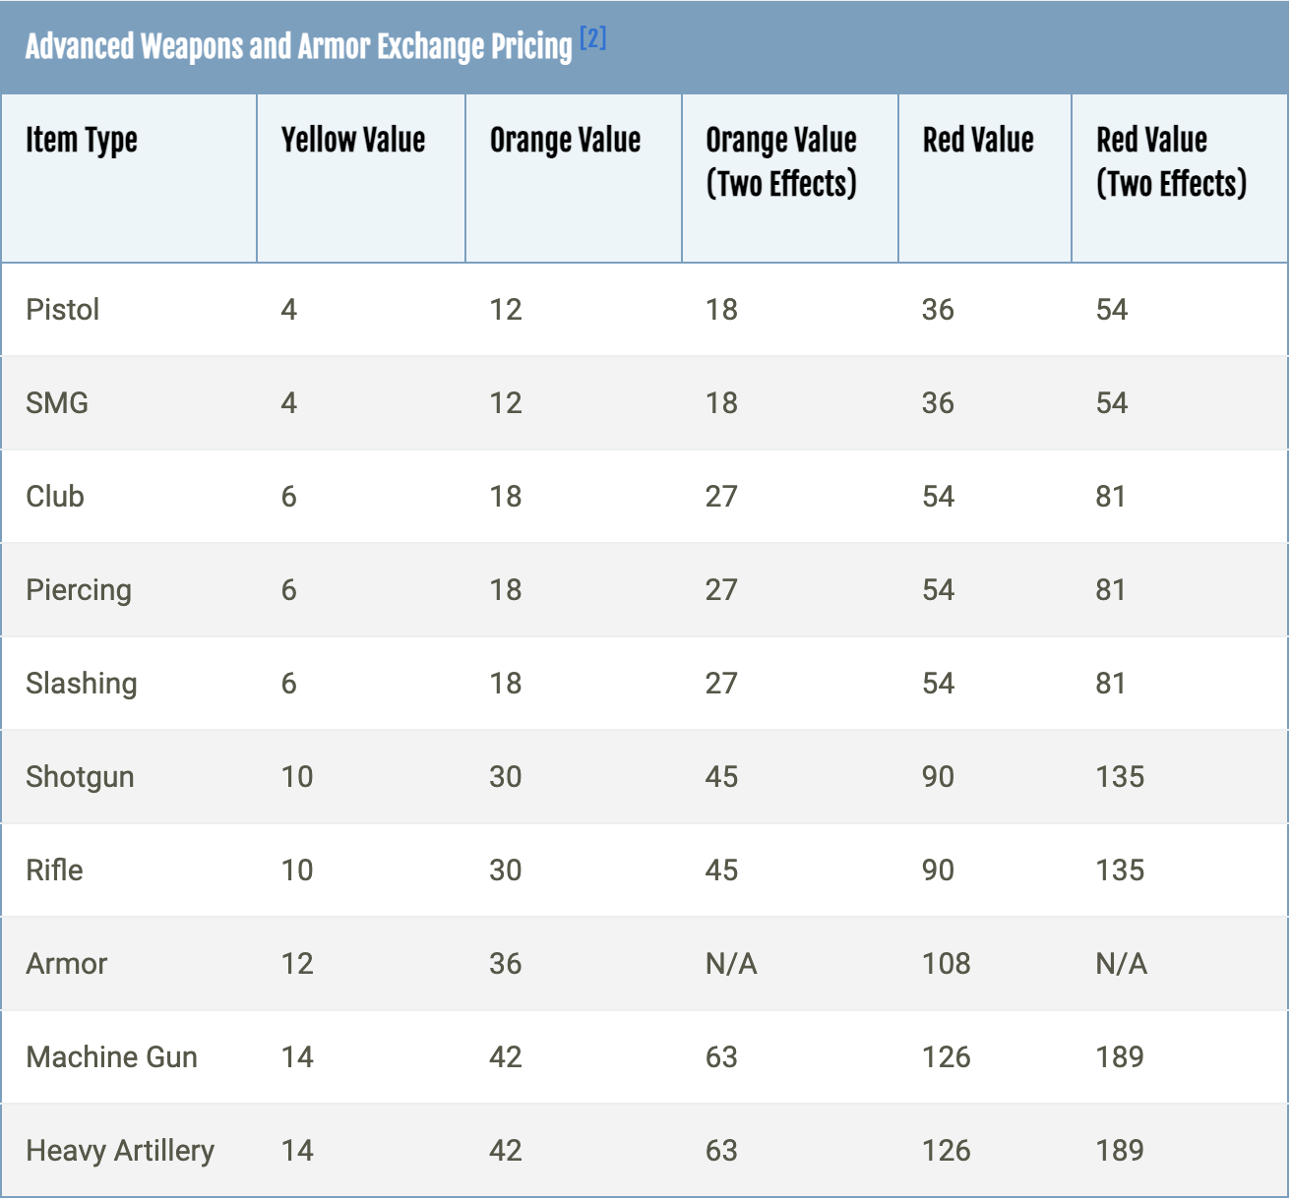
Credits to Torn wiki.

Item Market (Step 2-4)

- Check item market listings of that specific weapon/bonus
- Check item market listings of similar weapons with the same bonus
- Check item market listings of the same weapon with similar bonus

Item market is a decent reference on pricing, especially on popular yellow weapons. However, the price you see is usually quite a lot higher than auction/its "sell-able" value. There's a reason why the weps are still on market and not sold already, it's because their price is high. The actual "sell-able" price of the weapon is usually at most 85% of what you'll see on market, sometimes lower than that. Be careful!

Let's think about a scenario. Example 1 - You wanna bid on a 11% fury metal nunchaku you find on auction! What's a good bid for it?

First, you select metal nunchaku and fury bonus, this is what you see:
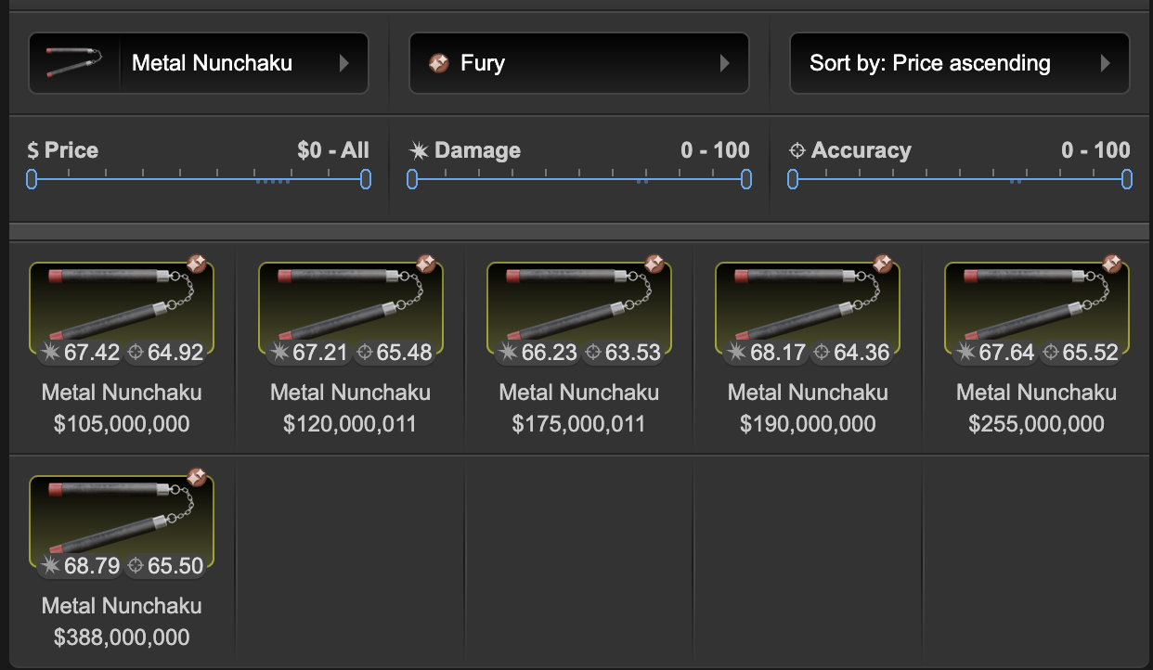
Check the first listing first, it's a 10% fury, pretty close to a 11%! - 105m
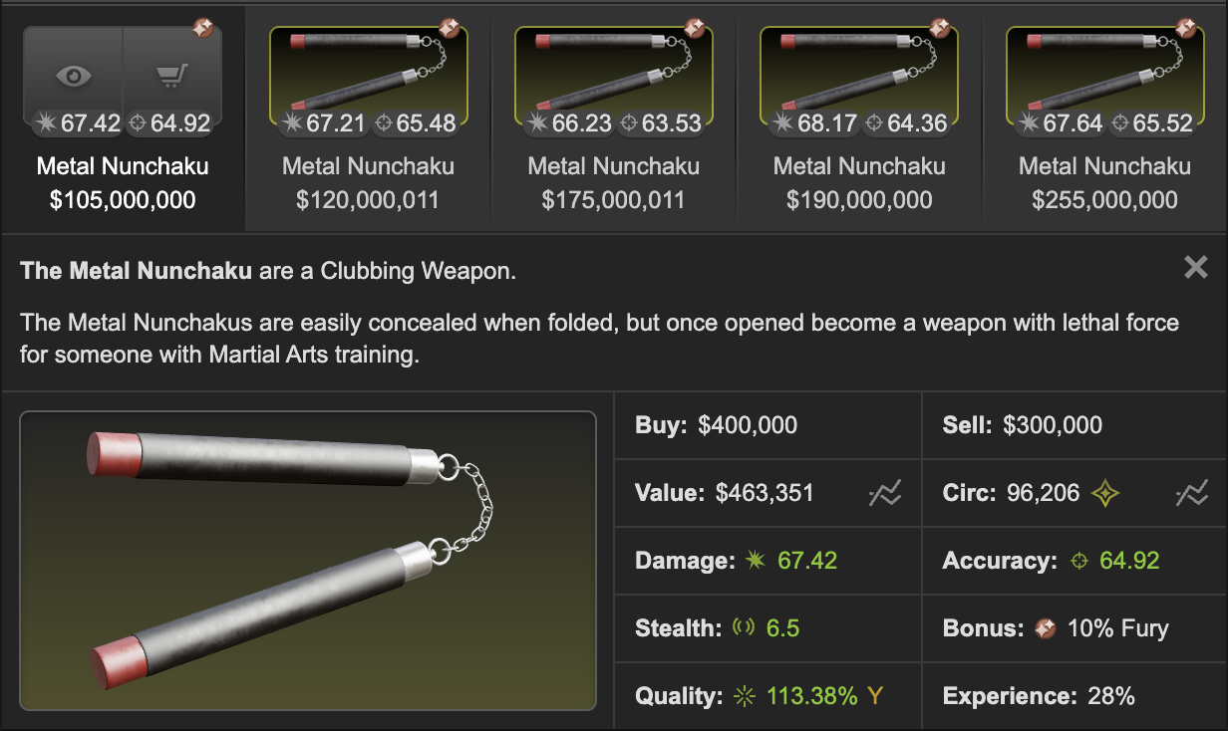
Let's double confirm and check the second cheapest listing, this one price isn't too far away. Lovely! This one has the exact same bonus % of what we're looking for - 120m
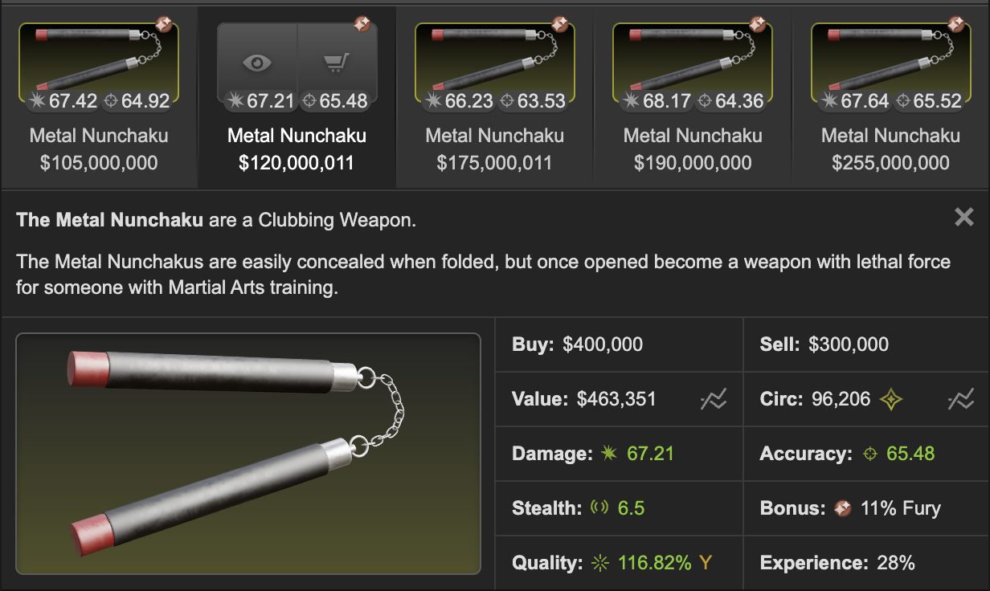
Do we stop here? Nope, better triple confirm and make sure what we have here is a good price reference.

Have a look at the similar weapons too. There really isn't a lot of similar weapons that mimic the damage/accuracy of a metal nunchaku. So let's go through the other good melees.
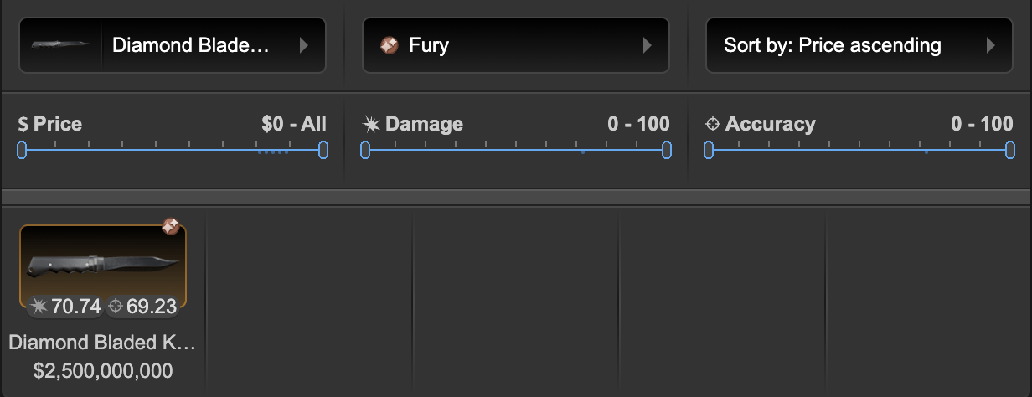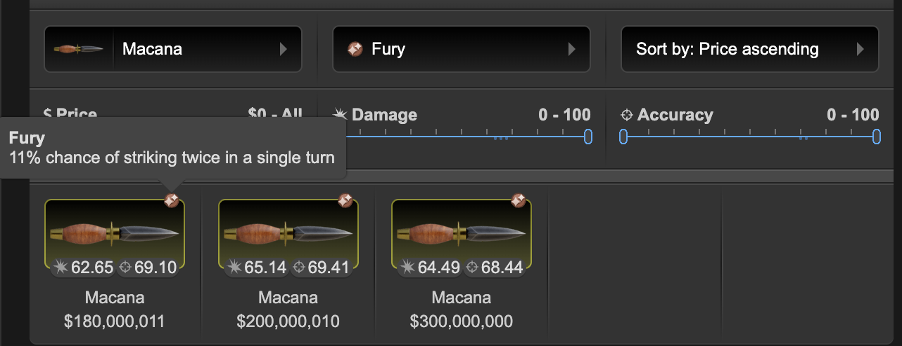
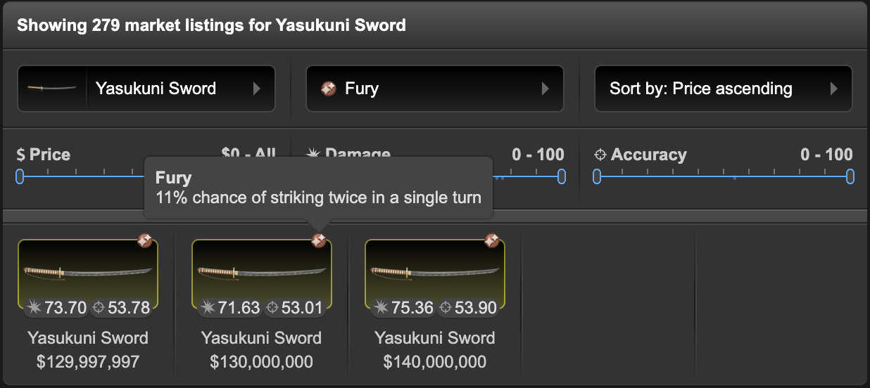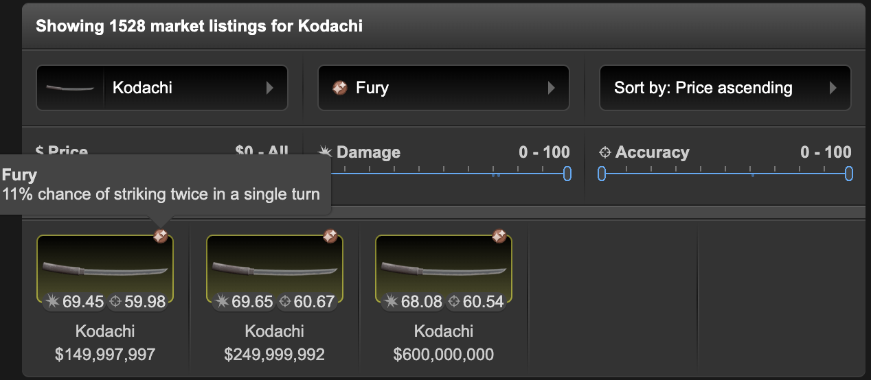
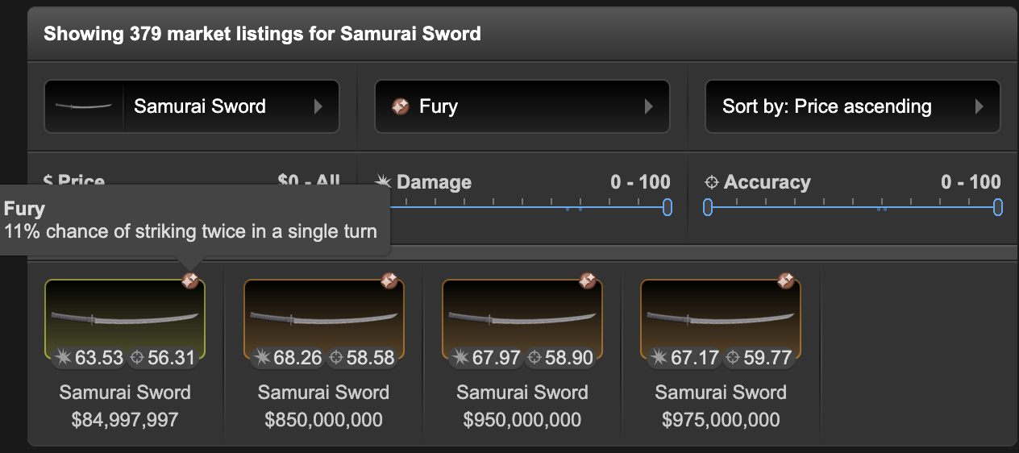
What do we wanna check here? We want to see if there are better weapons (kodachi/macana/dbk) with the same bonus that is selling cheaper than the 105m and 120m metal nuns we seen earlier. This time, they are all selling higher than the metal nuns.

For example, if we find a macana 11% fury selling at 75m, we need to really think about whether we should reference the value of the metal nunchaku listing. The real value of a metal nuns fury should be far lower if this is the case.

We also wanna check the listing prices of some slightly worse weapons. We can see a 11% samurai sword selling for 85m, looks reasonable to me.

Usually I will stop here but sometimes I try to quadrpule confirm - by looking at other bonuses that work similarly (e.g. cupid is close to achilles, slow works similarly as weaken or wither, grace is close to berserk) or has similar price points (you do need to know the market well to know this though - in my experience rage and frenzy are quite close to fury in my opinion).
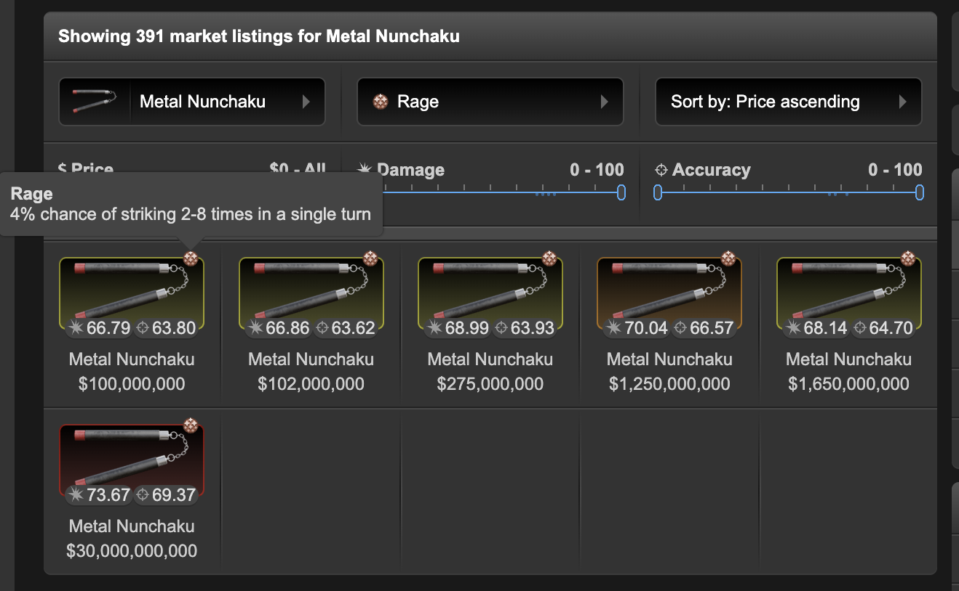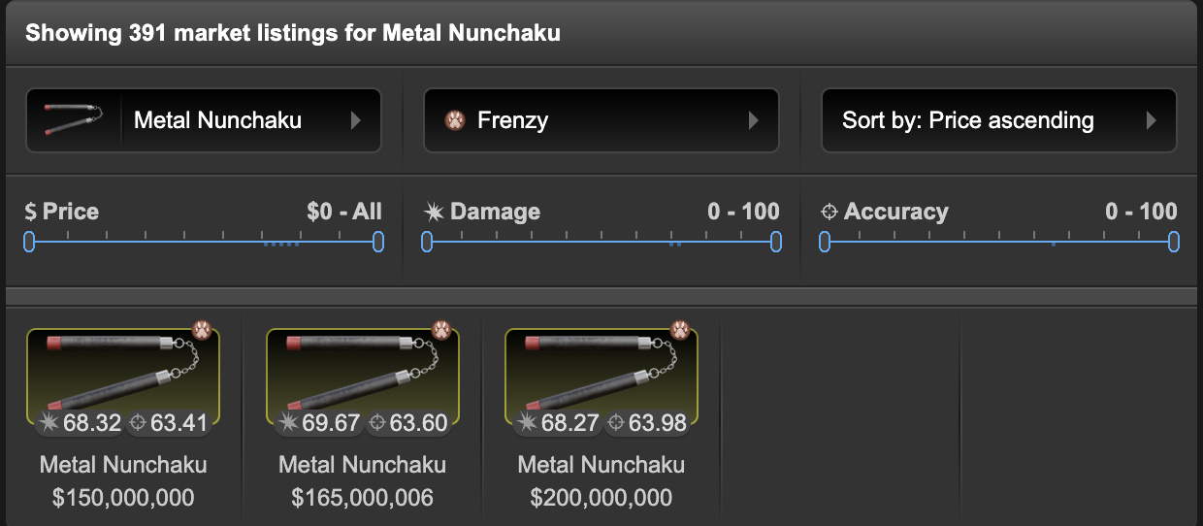
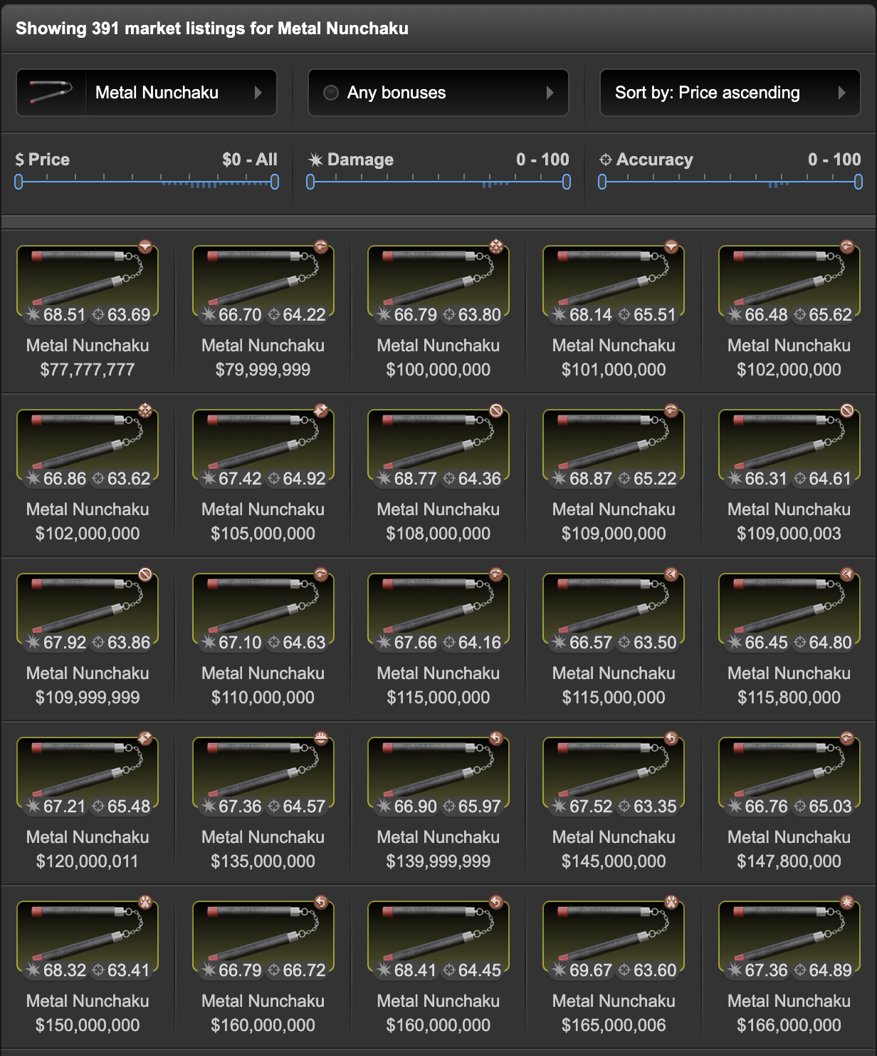
There's a rage that's slightly cheaper than the 105m fury metal nun we see earlier. Rage is usually a slightly better bonus than fury, although the price difference is so small - I won't take this into consideration.
At last we check all the bonuses. We see roshambo and stun cheaper than fury metal nuns. Roshambo and stun are worse bonus so it makes sense to be cheaper.

Now what are we going to do with the 105m 10% fury and 120m 11% fury you checked first? Since it's just a 1% difference and the damage difference between a 10% and a 11% fury isn't even noticeable, I will reference the cheaper one. Now, I will cut 20-25% off, why 20%? 5% market tax, 10% mug tax, another 5-10% in margins. So, we would want to bid no more than 79m to 84m on auction house.

Example 2 - Thompson 16% Warlord

Warlord is always easy to find price references on. There's already one here! 16% thompson - 175m

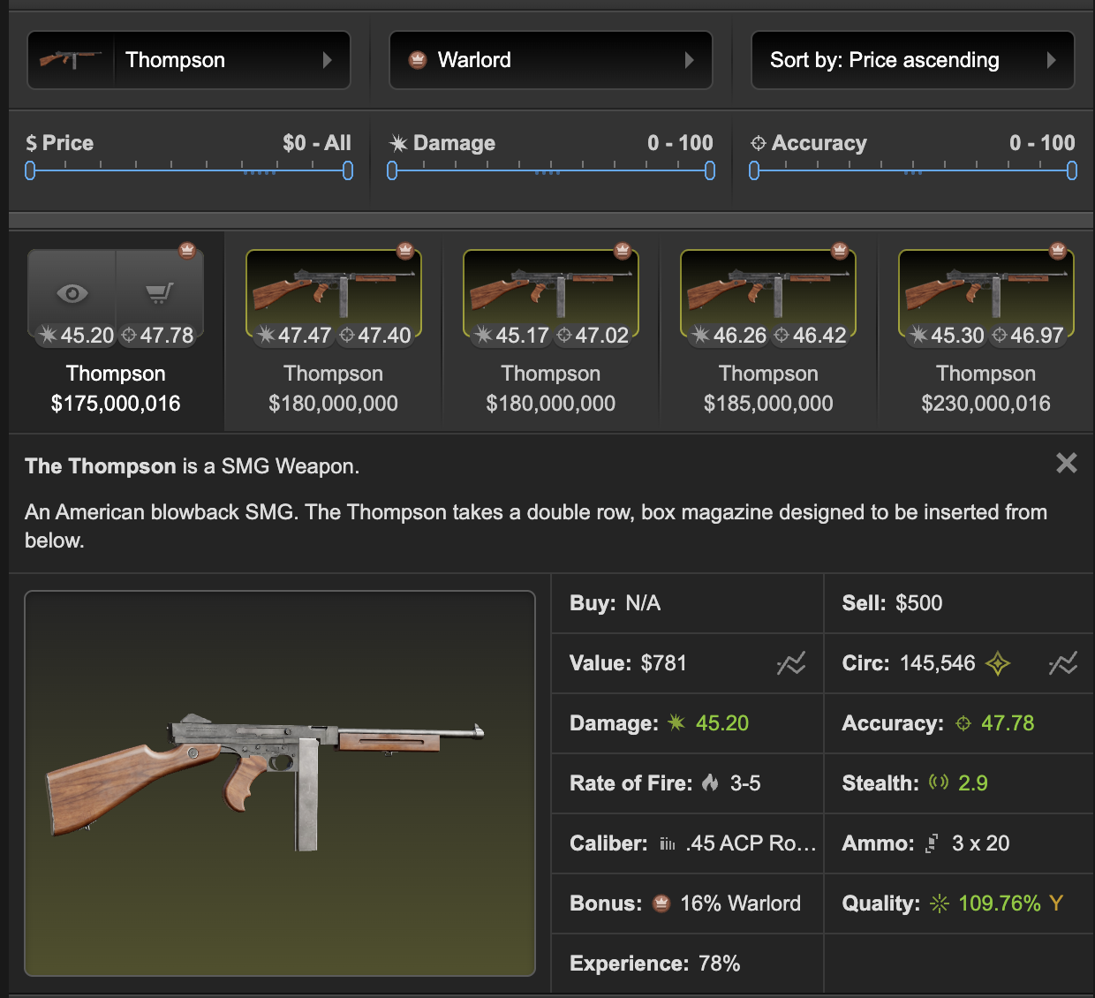
The second and third cheapest thompson are selling for 5m more, both 15%
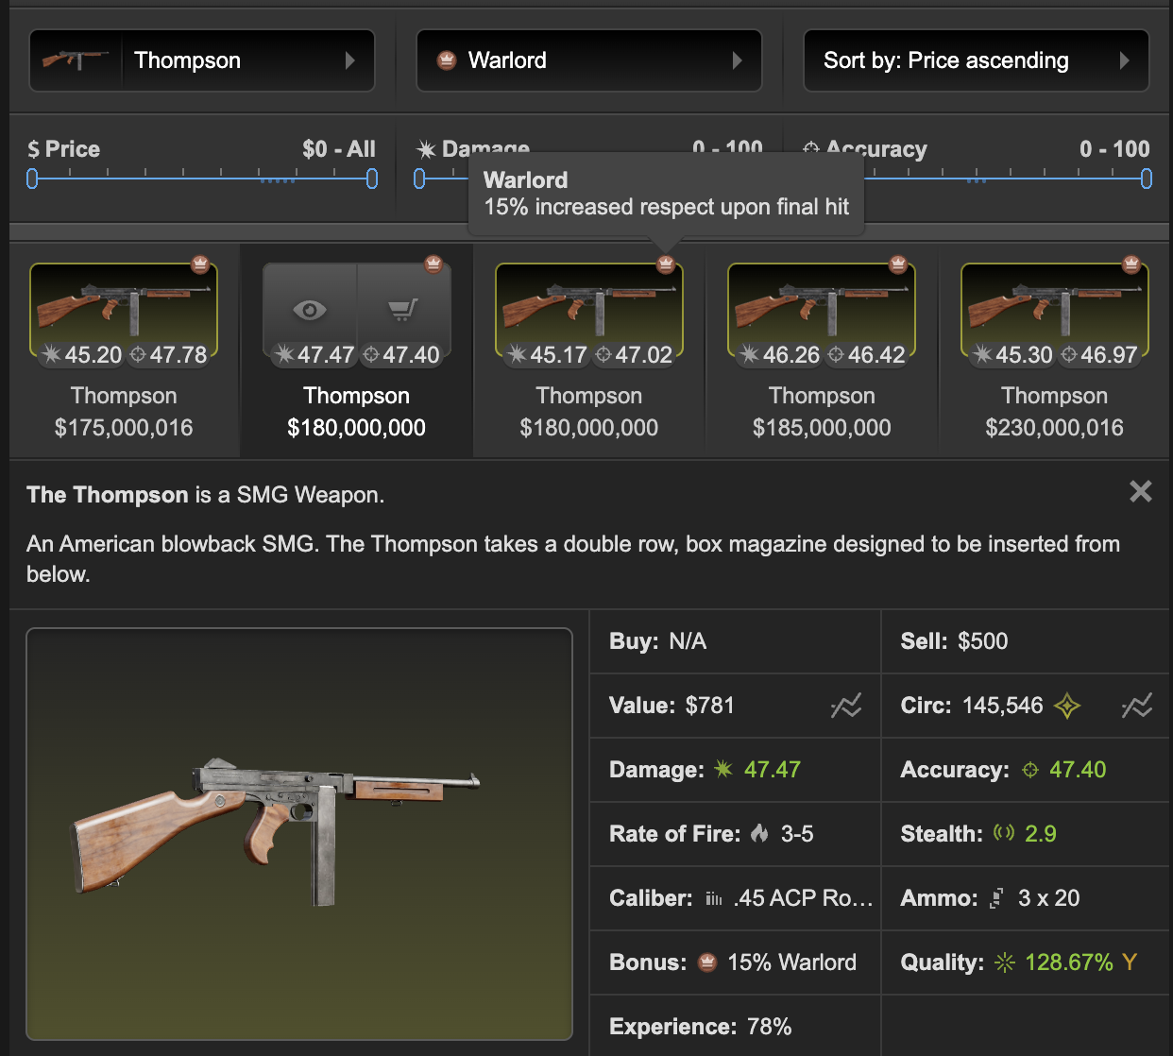
Remember we need to compare similar weapons to double confirm! Let's check mp40, which has similar stats than a thompson.
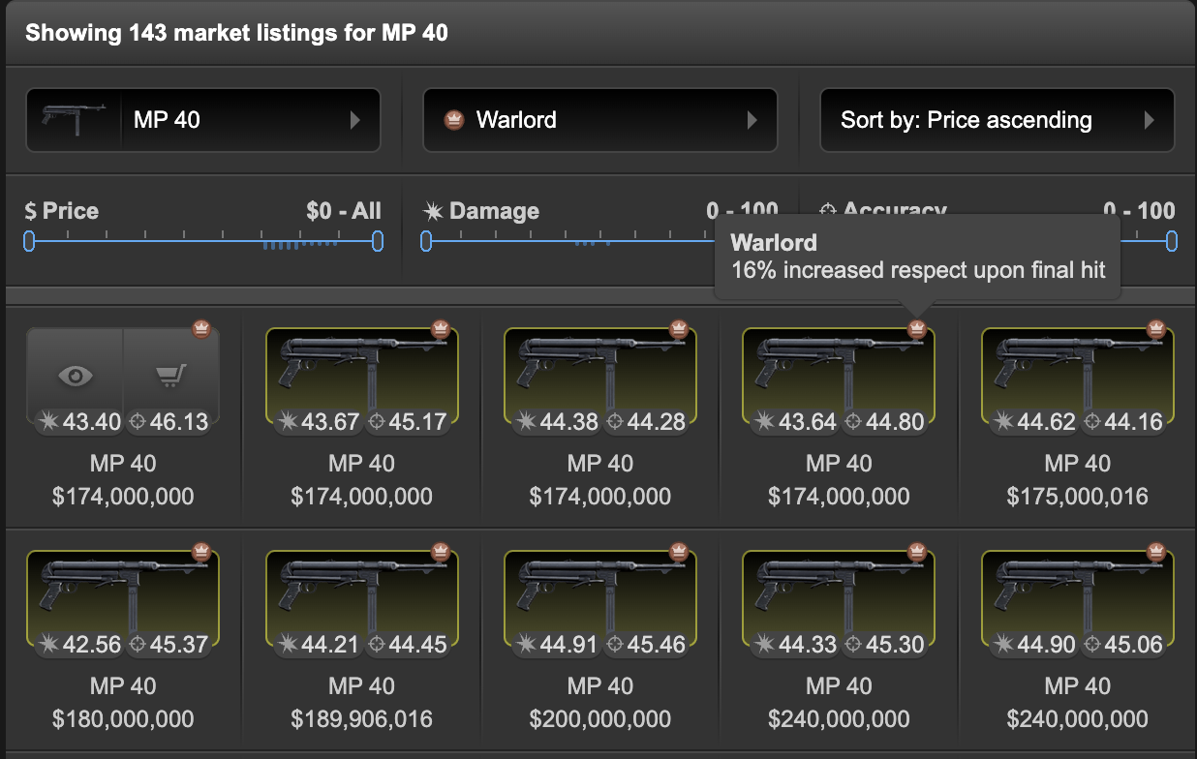
(The first 3 are 15%, fourth and fifth 16%) Very close to the thompsons' prices.

Let's also check the whole warlord market - there's a 16% sawed off selling at 160m. Even if it has a lot higher accuracy than a thompson, it has very bad rate of fire. It is reasonable to see it selling a bit below or equal to thompsons.
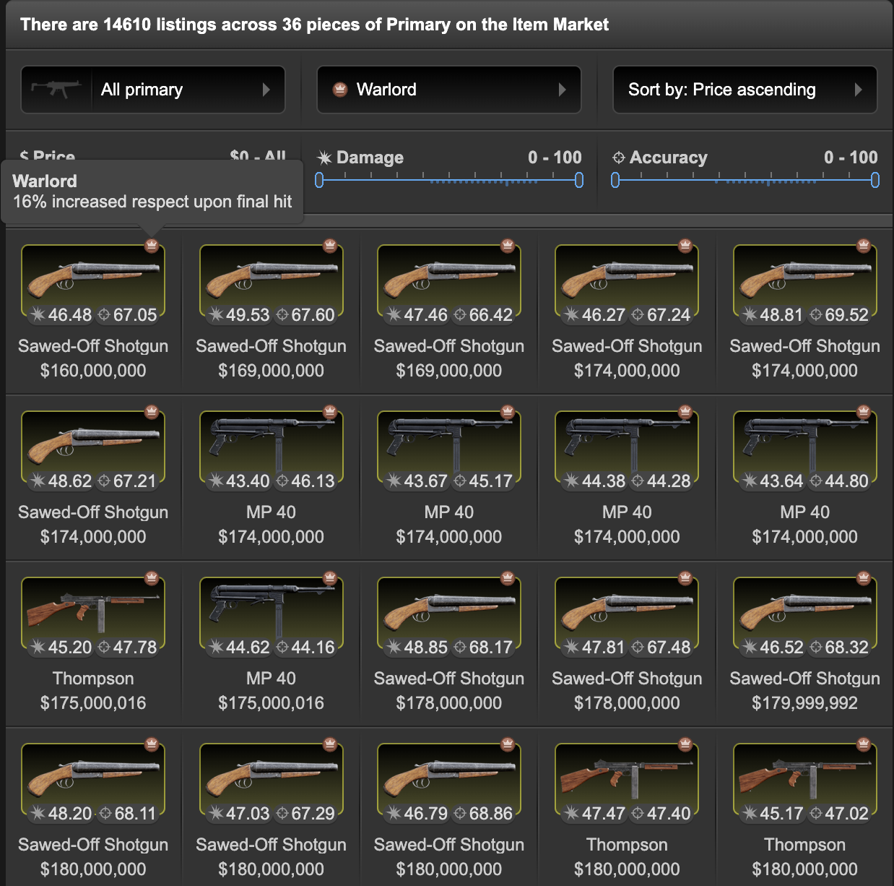
Warlord doesn't have any similar bonus (you can say revit's close but their price is just so different), let's just skip this part. Now we take the 174m thompson 16% as price reference, take 20-25% off, your bid should be - at most 130m-139m.

Example 3 - Samurai Sword 21% bleed

We already find two decent references here - a 360m 20% bleed and a 380m 22% bleed.

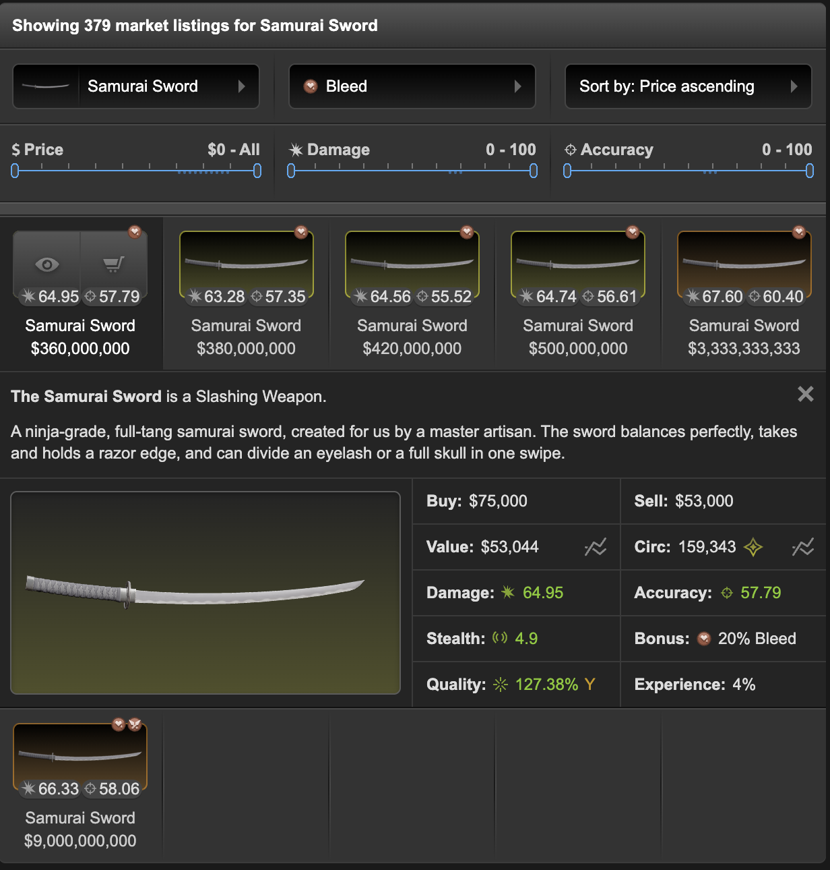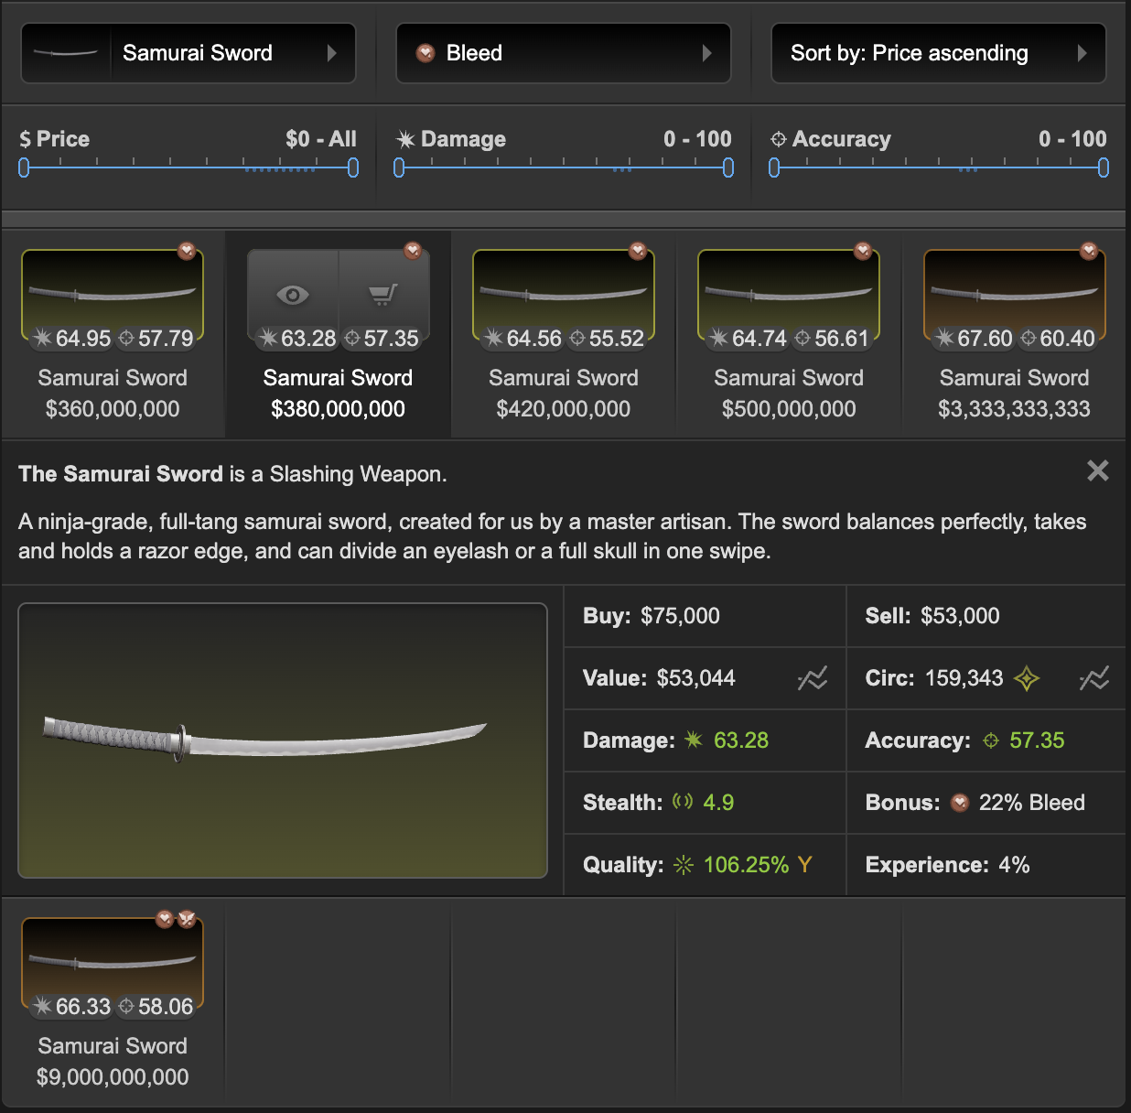

Let's double check and check the other japanese swords with bleed bonus!

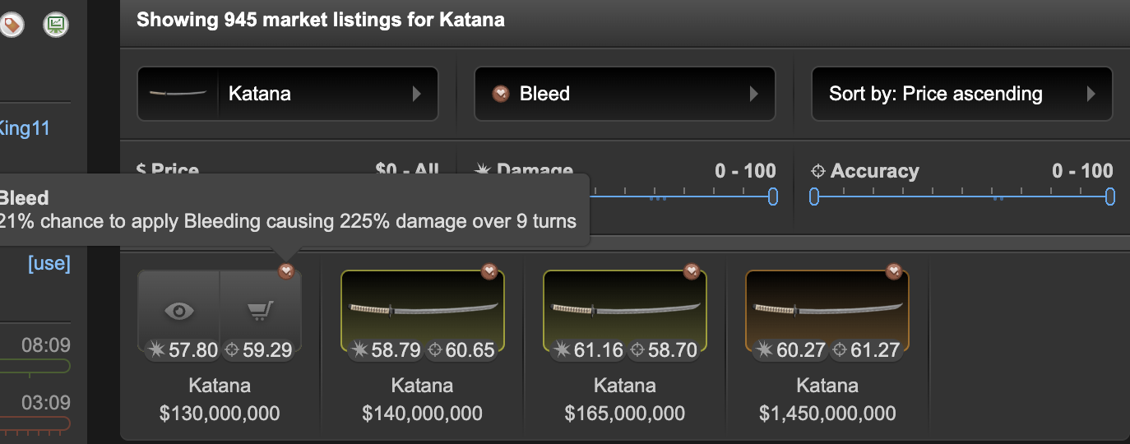

Katana is merely one tier below samurai sword. It's about 5 points less damage and even has 2-3 more accuracy than samurai. How come a 21% katana is selling for 130m? Now we'll really doubt about the samurai price we see earlier.
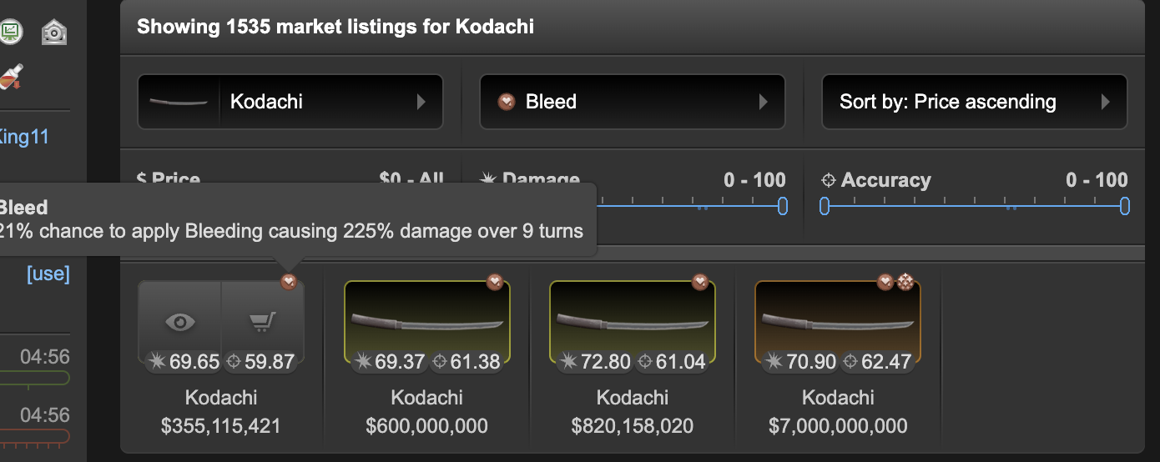
There's even a 21% kodachi selling for a bit below what the samurai selling for. However, kodachi is a lot better than a samurai.

Therefore, we can not reference the 360m/380m value of the 2 cheapest samurai listings. What should you do? There's two ways I recommend - 1. Stalk auction house for similar weapons, which I'll discuss in the next section. 2. Estimate the price of a samurai based on the katana. You can take a wild guess and think +20% of the katana bleed price should be the normal samurai bleed selling price. So what you bid will be 130x120%x75-80%= 117-124m.

High Quality/High Bonus % Weapons

A high quality yellow weapon usually has 130%+ quality, a really high one 140%+. A high quality orange is 200%+ and a red is 300%+. If the weapon base is good (like armalite, dbk, kodachi, btmp9, sig 552, etc.), having high quality pushes up value significantly. I often excludes them when finding price references, some people pay crazy money when they see a high qual gun. High quality doesn't matter much in bad bases.

Low quality (<100% for yellow, <160% for orange) has effect on prices too, but usually less significant.

High Bonus % means the higher end of the "range" . Let's use warlord as example, with a yellow range of 15-19% (rarely 20%). Pricing doesn't change a ton between 15-17%, but at 18-19% price curves up a lot. E.g. if you're looking for a 19% warlord, only check the 19% listings, the 15-18% isn't really a good reference. Another example is empower/quicken, prices from 50 to 70% goes up pretty slow, ~80%+ it's a whole different world. It's fine to reference a 55% or 65% if you're looking for a 60. But not a 80%.

Double Bonus Weapons

Double bonuses weapons are usually overvalued, I won't suggest buying one unless the weapon synergize very well with your builds. It is also more difficult to resell them.

--> As you can see, all the examples above are based on yellow weapons. It is really difficult to estimate the value of a good orange/red, double bonuses, niche or high quality/high bonus % weapons. They have very few price references on market and are usually too unique to price well. It generally becomes a "worth what the buyer is willing to pay" situation. This is also why orange/red weps have crazy margins, as long as you find the right customer.

Pretty handy script from Snickelfritz if you wanna sort by quality/bonus %.
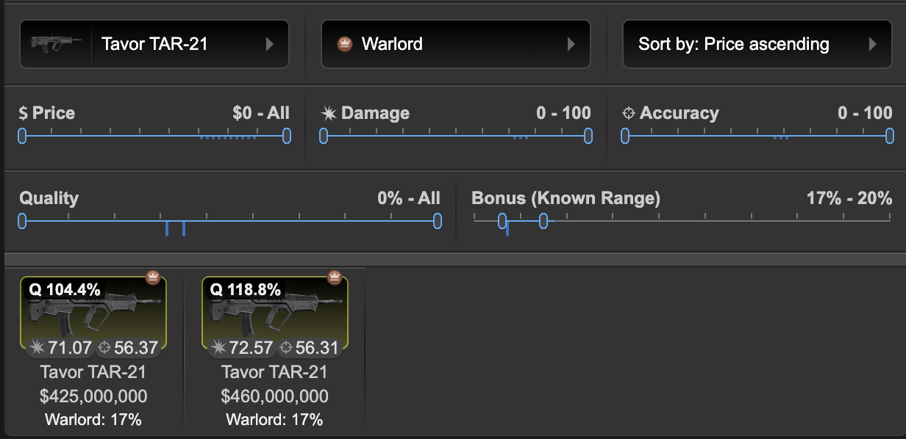
How auction works

Number 1 place to buy RW gear. This is usually where traders get their stuff too. Quick rundown on how it works:

It is a lot different than real life auction. Let me give an example:

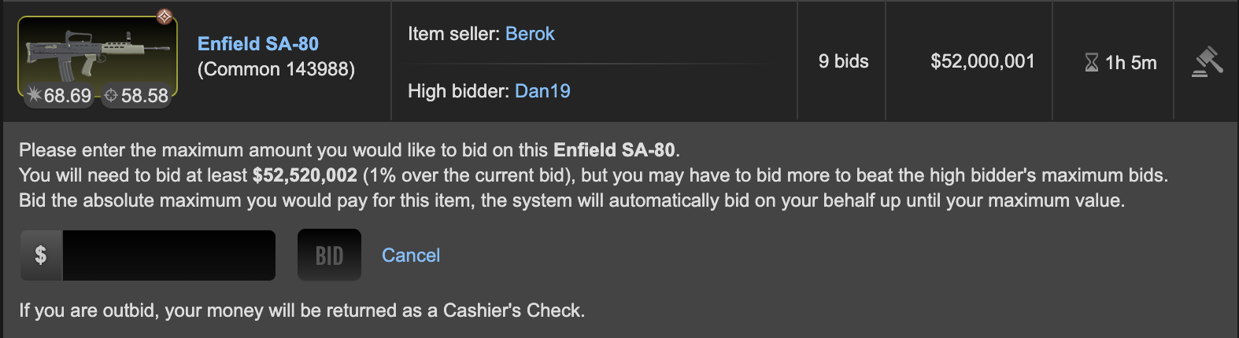

First thing to note, the "$52,000,001" shown here is the bid of the second highest bidder (the second highest bidder bidded 52,000,000, the auction system will add 1 dollar, not something you should bother) , this is not Dan's (the high bidder) bid. Dan's bid can be a bit higher than 52,000,001, or a lot higher than that. You don't know how much he has bidded!

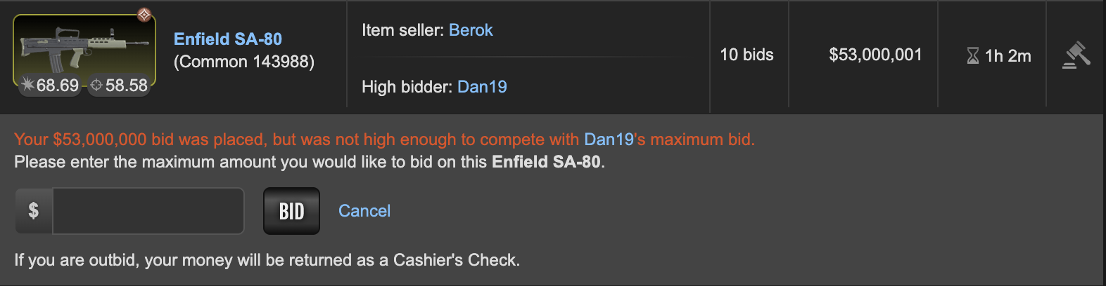
Now, I am going to try and bid 53m. However, Dan's bid turns out to be higher! It is now at "$53,000,001", making me the second highest bidder of this weapon. However, it's still not enough to compete with his maximum bid.
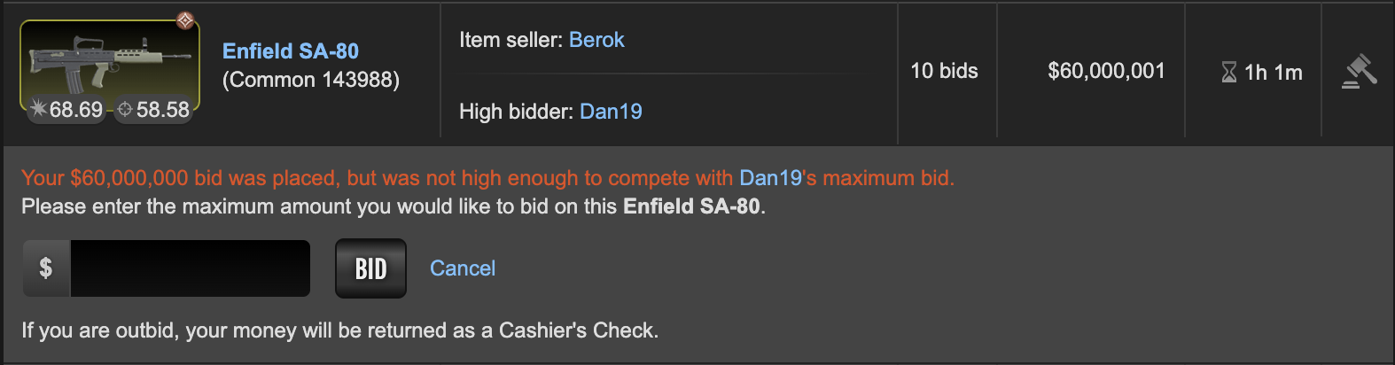
I'll go higher and bid 60m. Still not enough!
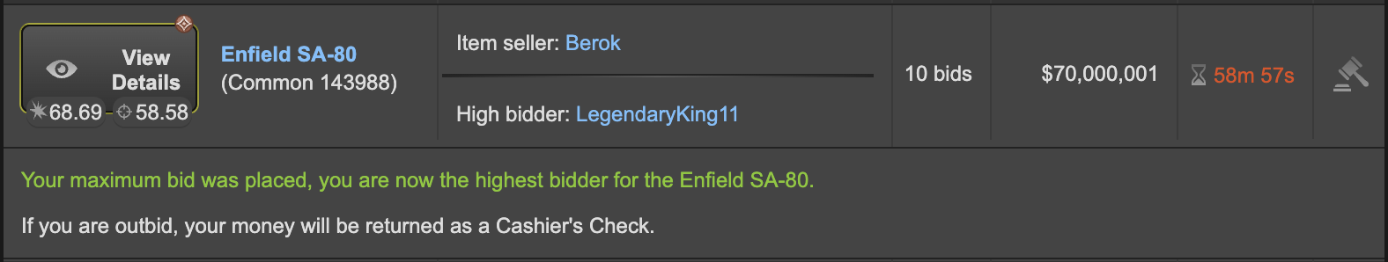
I'll go more and bid 80m. This time, I "outbidded" Dan. It turns out his bid is $70,000,000 (70,000,001-1)
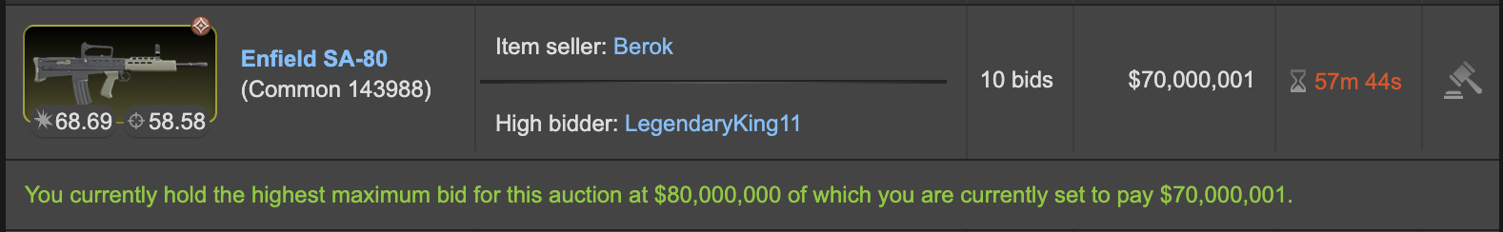
Clicking the gavel again and I can see this message. If anyone wants the weapon, they need to bid more than 80m to "outbid" me. If they bid only 71m, 75m, etc, they won't be able to do so.

The price you pay for the RW item will be equal to how much the second highest bidder is willing to pay + $1, any money left over will become cashier's check. In this case, if no one bids me up, I'll get 80,000,000-70,000,001=$9,999,999 in cashier's check + the weapon. If someone bids 75,000,000, I'll get 80,000,000-75,000,001=$4,999,999 in cashier's check + the weapon.

Most bids come in the last 2 hours before an auction ends. Don't get surprised by the cheap bids in the second/third page in auction.

If I get outbidded, the full 80m will become cashier's check. I need to withdraw the cashier's check within 24 hours, or it'll be transferred straight to my wallet, which leaves me vulnerable to mugs.

The timer will reset to 1 minute every time if it receives a bid below the 1 minute mark. This prevents bid sniping. I do not recommend bidding last moment - more on this later.

Bids cannot be cancelled. You cannot rebid a higher bid if no one outbids you.

Wiki excerpt:
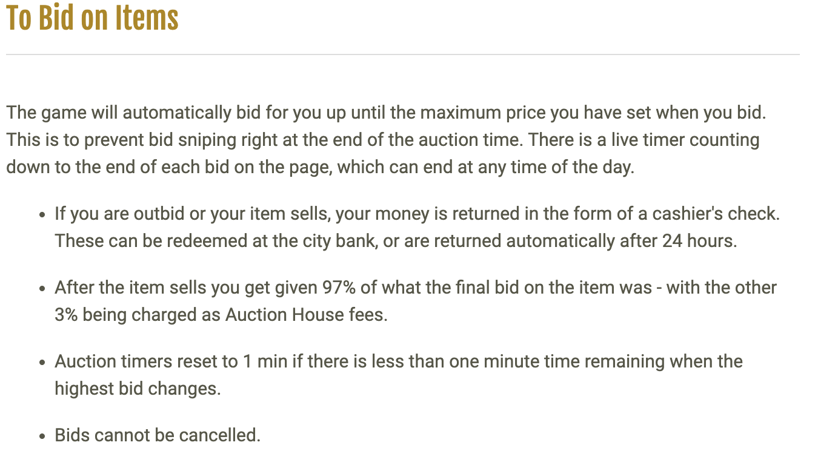

How to stalk auction prices (Step 5)

Starting from 9/1/2025, Torn API is integrated in auction house and you can use it to find out information about finished auction. This includes the sale price, buyer/seller info, auction end time, weapon/armor stats and the amount of bids made on it.

More info on this later! I am working with several scripter to develop a script to regularly pull logs of finished auction and filter it, let us cook :)

For now you can use this website to review auction logs in 2025 - https://www.neckchin.dev/torn/auction-house-records/e7cf?quarters=q4-2025

The flowchart for finding price references should also be much different as well, since market and forum "prices" are generally inflated and much less reliable. More updates later.

Tips and Tricks to get better deals in auction

There are a few things you should look out for when outbidding people:
- Safe bids - Some people may ask their friends to bid up their weapons, you may end up getting a bad deal if you win the auction. Be very careful if you notice any of these: 1. Seller is a trader 2. Seller and highest bidder is in the same faction 3. Seller and highest bidder are married.
- Noobs/p2w players - Plenty of noobs or pay to win players are overpaying in auction. If the highest bidder is <365 days old, below level 30 or have a blue name, be careful when you're outbidding them. Sometimes they even bid higher than the listings on item market, don't ask me why.
- Faction leads/co-leads - Not the kind of people you want to entirely avoid outbidding, but usually they don't really care getting the best deal just so they can fill up the armory... so be careful.

Who you should outbid -

- Top traders - If they think it's a good bid, it's usually a great deal for you! (Oh yes are you going to outbid me for that? Betrayal!)

So many people try to predict a time frame that auction is "slower" and stuff goes cheap. It's just a myth. I have never reliably predict when auction will go slow. I do notice these three phenomenon:

- Certain holidays - e.g. close to the start of halloweek, people spend their time attacking and dealing with lags instead of bidding
- Most auctions end between 14 TCT to 02 TCT - It correlates to the higher torn activity at these time frame. This does not mean stuff will go cheaper or more expensive if you buy it at this time frame.

Should you bid last minute or bid early? Fighting bids last minute may lead to behavioral mistakes (you keep bidding more and more and end up overpaying) and risk auction mugs. But yes, you'll usually get a slightly better deal bidding last minute, but remember to always protect yourself from mugs and set a hard limit on your maximum bid before you start bidding.

It takes the system 30s to 2 minutes for outbids to show up in events. So, if you're gonna rebid last minute, stay in the auction page and keep refreshing it. Don't rely on events and notifications to tell you whether you get outbidded.

Protect yourself from auction mugs - You may get mugged when bidding in auction house, especially when bidding last minute. Always have a ghost trade aside and minimize the time you'll be holding any money in your wallet. One tab for auction, one tab for the ghost trade and one tab for items (for medding out).

High value auctions are often watched by muggers. If you get outbid and do not intend to rebid, don't withdraw your cashier's check right away.

Cashier's checks are automatically transferred to your wallet after 24 hours. Don't forget to withdraw it before the timer ends or you may get mugged.

You can use torntools to filter out what weapons/armors you wanna search for:
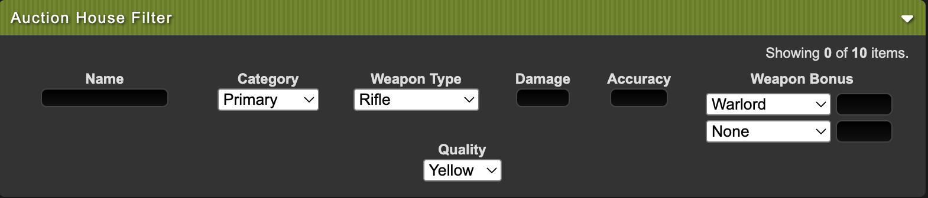
If you wanna save a bit of time in clicking into the wep to check its bonus % and quality, this script helps too
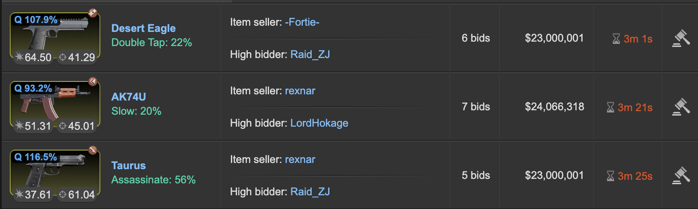
How to research prices (armors)?

- Does it have base stats only? (Base stat = usually <25% quality, at the lower end of bonus e.g. 20-21% for assault 20-29%) - If yes, go to step 2 or 4, If no, go to step 3. If it is an orange/red, go to step 5.
- Is it dune or riot (excluding riot helmet)? - If yes, try to buy as close to bunker bucks as possible
- High quality/bonus % dune/riot/assault - bid no more than x2 (or x2.5-3 if very good) than the price of a base stat armor.
- Low quality/bonus % assault - bid 10-20% below current MV on auction.
- Orange/red - Check market price graph in the last 3 years
- Ask traders

Dune/Riot = Bunker Bucks

Dune/riot prices are usually correlated to bunker buck values, often not more than 25m than bb prices. It's quite easy to hunt them in auction at bb or very close to it, as long as you aren't demanding one with good quality and high bonus %. Excluding riot helmet because of its special role in assault sets.

Assaults

Assault armors are a lot more interesting, market's flooded with them but has no sign of getting close to bb except assault helmet sometimes.

I'll say don't think about it and try to bid 10-20% below the current item market value on auction.

Hunting high quality/bonus % pieces

NEVER BUY DIRECTLY FROM ITEM MARKET. The listing prices on market for high quality armors are unhinged. Usually 3 to 4 times compared to base values (price of the cheapest listing of that armor piece) even if it's just some 40-50% quality pieces

Try to buy them at no more than x2 (or x2.5-3 if the armor piece really has very good stats) compared to base values from auction. Or you can hunt for good armors in forums and get a nice deal privately.

Orange/red armors

If you want a price reference, check the market price trend in the last 3 years. You'll notice most of the prices stay more or less the same for years, sometimes it's even higher than before, but RW gear is supposed to depreciate in value over time, not too sure what's happening here. In general... this is a very weird market, erratic price movements - My advice is, take your time and buy them from auction one by one. Alternatively, go to forums and check if there are any end users liquidating their sets, they can usually give you a better deal.

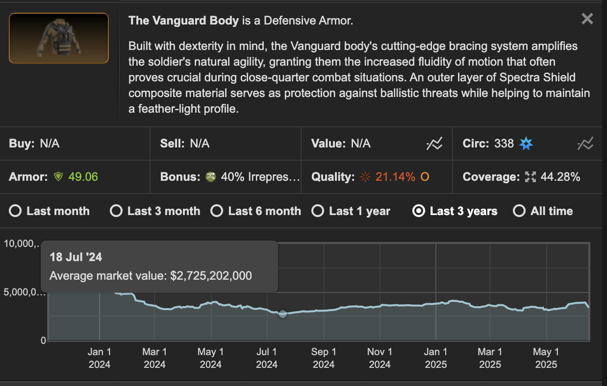

Forums (Step 6) - Trading Post

Forum prices can be an OK secondary price reference, take note it is usually higher than the item market ones.

Do not use the search function. It's flooded with traders spamming their bumps with keywords.

Important forum threads:
- Red weapon selling thread
- Orange selling thread
- Trading post guidelines

Bazaar (Step 7)

- https://torn.bzimor.dev/items/weapons/all - Item market, display case and bazaar listings in one page. Credit to bzimor
- https://algisk.shinyapps.io/Chedslist/ - similar functionality as bzimor's website. Credit to Omanpx

Till now, most RW traders still list their stuff through item market so you won't find much in bazaar. Ofc it's fine to check bazaar as a secondary reference tho.

Useful Tools/Websites/Spreadsheets (Step 8)

- https://www.torn.com/forums.php#/p=threads&f=2&t=16528580&b=0&a=0 - 2025 Full Auction House Records, including RW weapons and armors, about 100k total logs. (The method used to scrap this data is now illegal, do not attempt this.)
- https://docs.google.com/spreadsheets/d/e/2PACX-1vTD3Lg4jdpaUIpxOC4USJhRp3rJOEfDRTaC9J8fUqGenJIH-iaswshfFPwj9P9-nMH5gyDW_JwId-16/pubhtml?gid=0&single=true - Auction records from July 2025 to December 2025 (The method used to scrap this data is now illegal, do not attempt this.)
- https://tornexchange.com/rw_listings?page=1 - Include both item market and bazaar listings. Weapons only. Credit to Ata
- https://weav3r.dev/ranked-weapons?itemType=Weapon&sortBy=price&sortOrder=asc&page=1&limit=50 - Bazaar and market listings. Credit to Weav3r
- https://torn.bzimor.dev/items/weapons/all - Item market, display case and bazaar listings in one page. Credit to bzimor
- https://www.torn.com/forums.php#/p=threads&f=67&t=16469095&b=0&a=0 - Display item quality and bonus on item market/auction/display case. Sorting by bonus % and quality on item market. Credit to Snickelfritz
- https://algisk.shinyapps.io/Chedslist/ - Similar functionality as bzimor's website. Credit to Omanpx
- https://drive.google.com/drive/folders/1-hDwR1P9EXgGuXKKhUC7kx8N-Z7LGdG_?usp=sharing - My auction records, most records come from 2024 so it may not be accurate

If you're still not sure, you can ask other traders' opinion on prices. Be nice when you're asking though.

Buying from traders/item market

I don't suggest you to do so if you're looking for the best deal. Most traders have a pretty big mark-up on their products, you'll usually do better buying from auction. Of course, you may get tired waiting for what you want to show up in auction, or the wep is so niche you can only buy from a trader.

Again, ALWAYS do research before buying any RW gear (refer to the previous sections). After that, message the seller and ask for a MINIMUM OF 15% discount from the market listing price. Why 15%? Market tax is 5% and mug loss is 10%. It's totally fine to ask for more, but don't go too far or it'll be lowballing, which is very offending. If the listing's on forums, also a minimum of 15% from forum listing price, most traders expect you to negotiate down at least 10% so 15% will be a good starting point.

Don't bother to buy from traders or sellers that don't even show their buyout offer, unless it's a good orange/red wep that's hard to pinpoint values.

"obo" means "or best offer", this means the seller is inviting you to negotiate. "c/o" is the current highest offer. "b/o" is buyout. [B] means buying. [S] means selling.

Negotiation tactics

- Meet in the middle - Funny enough people are surprisingly receptive when you say this. E.g. Me: 200m for the ak warlord? Seller: 250m maybe? Me: Meet in the middle and 225? Seller: ok deal
- Round it off - e.g. (Seller counters with 205m) --> Can we round it off and do 200m?
- Give evidence based on similar weapons/armors on the market - Most traders are happy to at least match the price you see on market. You can also point out a similar or better wep is cheaper than the listing price as leverage. Say it in a way that's not rude tho.
- Threaten to mug the seller - Looks rude but you can say something nicer like "is there a mug tax included in this listing?", exception is the seller is in a clothing store, although most clothing store traders are usually happy to give you the full 10% mug discount.
- The "frequent customer discount" - Applicable if you have bought stuff from the trader before. Or the seller is a factionmate or friend.
- The "bulk" discount - Applicable if you are trying to buy multiple weps/armors from the trader.
- NEVER BUY FROM ITEM MARKET WITHOUT NEGOTIATION. ALWAYS NEGOTIATE!!!

I don't recommend you to do swaps or non-cash offer, it usually makes the trade complicated.

Please be nice to traders. Trading is rough and exhausting. Remember, the trader just wanna profit, and you wanna get your fighting gear. No point to harass anyone if the deal doesn't go your way. Just say thanks and move on if you don't like it. Please don't rush an answer or expect the trader to answer you immediately, they have a job outside torn too.

After you finish the trade, like and leave a comment on the trader's forum thread if they have one.

Small remarks on market manipulation/price fixing

This is something you should be cautious about - some parts of the RW market are heavily manipulated by certain traders. For weapons, you can see if it's manipulated by checking whether a single trader is holding 3 or more of the same weapon bonus/type + he has the cheapest listings among the other listings. Armors are usually manipulated anyway. To be honest, there really isn't much you can do. You can try to grab them cheap in auction but the manipulator will just bid you up (still it'll be cheaper than directly buying it from him!). I suggest you to try buy these weps through private trade, although the seller may still reference market price and refuse to give you a reasonable deal. Try to look for alternatives if you are willing to.

Selling RW weapons/armors

Just a quick paragraph on how to sell your gear if you are not a trader. EXPECT LOSS, especially on stuff you have bought a long time ago. Please lower expectations on how much you'll get. DON'T SELL GOOD WEAPONS/ARMORS TO TRADERS! They usually offer below auction value, you can do better auctioning yourself.

My recommendation is:
- Bunker buck weapons (not armors) - Sell it to a trader that buys bunker buck weps, alternatively, just do a 1 day auction.
- Dune or riot gear - 1 day auction, don't bother safe bid.
- Yellow weapons/armors - 1 day auction with a conservative safe bid
- Good orange/red weapons/armors - 3 days+ auction with a conservative safe bid, while advertising on forums and orange/red weapon selling thread

Forum etiquette - Strictly post in trading post, don't bump your post for more than once every hour, no more than 2 concurrent posts at the same time. Details here. In your post, you don't need to show off fancy battle logs or hard sell how good your wep is. Just say what you have, when the auction is gonna end and include a screenshot of the weapon/armor's stat.

I do not recommend trade chat, which is usually for item traders. In my experience I rarely get deals even after spending hours advertising there, so don't bother it. Also don't recommend you to advertise in faction or company chat, it'll look spammy. Any discord #trade channel is fine.

Safe bid/Reserve bid is very important, there's always a small chance your gear will be sold far, far, far lower than normal market value on auction, rarely even below bunker price.

How to safe bid?

Simply put, you find someone (like a friend) to bid on your listing. He will bid a price that you're satisfied it is sold for. If no one bids higher than that, the safe bidder will get the weapon and trade it back to you. Revisit the earlier parts on how to value RW gear and determine how much it should go on auction, minus 10-20%, this will be the safe bid.

I suggest you to ask for a safe bid early, don't safe bid last moment, you may forget or your friends may not be online at that time.

A trick to "bait" outbids is don't bid "whole number", if you want 500m for your wep, don't do a 500,000,000 safe bid, rather do something like 499,999,998 or 497,928,173. So anyone that bids 500,000,000 on it will outbid the safe bid.

If you have re-auctioned the same item for more than 2 times, it is time to lower the safe bid or wait a while before auctioning it again. Remember there's a 3% fee for auction sales.

Section 2:

What RW gear should I get?

There are already plenty of guides about this, I will try to fill in the gaps here :)

Read this and this first to understand the statistics on a weapon/armor: E.g. what rate of fire, stealth, quality means etc.

Avoid weapons that performs worse than a non-RW armalite

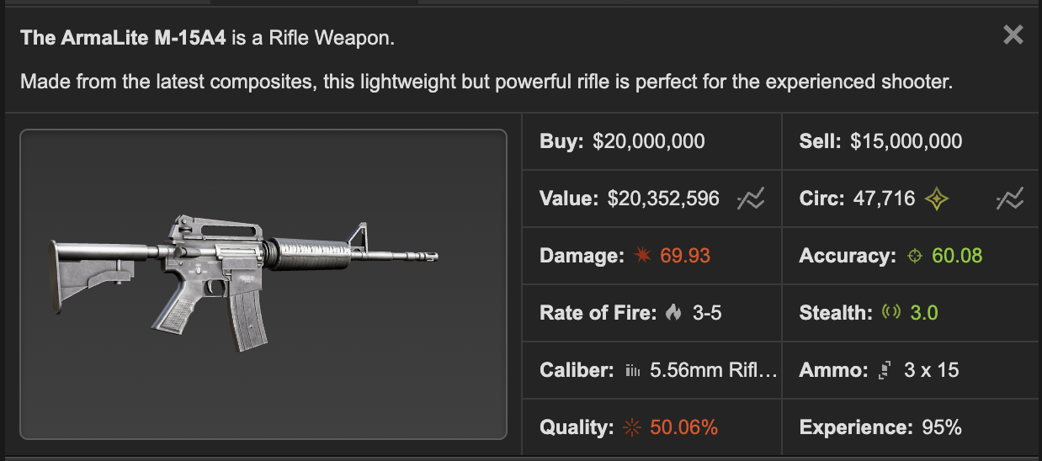

Keep asking yourself, can the RW weapon you want perform better than this thing?
- Is the base stats (e.g. damage/accuracy) of the weapon better than this armalite?
- Does the weapon have any niche or specific use that applies to your situation? (e.g. using warlord in chain)

If it's a no, the weapon is trash and usually worths only bunker bucks. A few examples to illustrate my point.

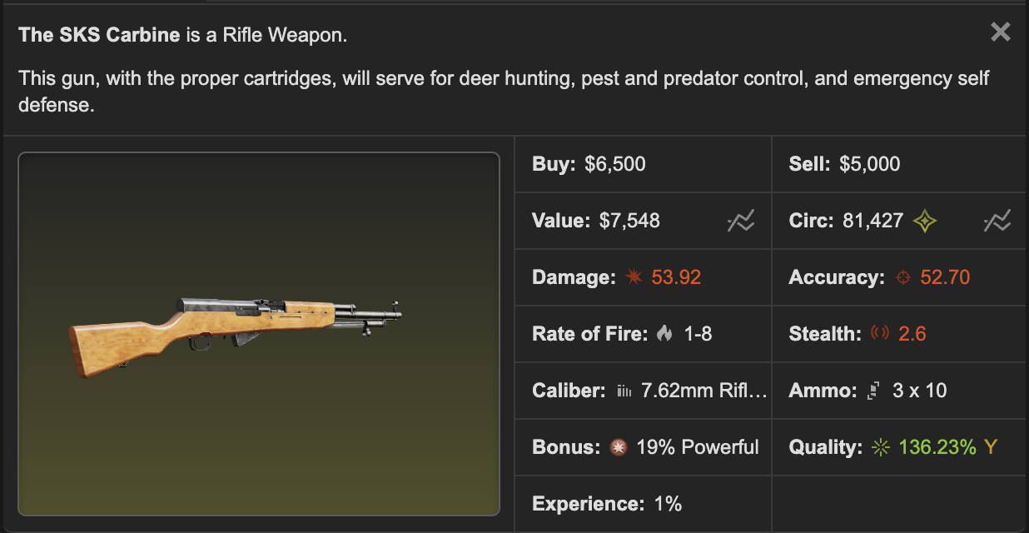
Example 1 - Let's say we add 19% on the damage, 53.92x119% = 64.16. The end result is 64.16 damage/52.70 accuracy, which is worse than the armalite 70 dmg/60 acc --> it's trash!
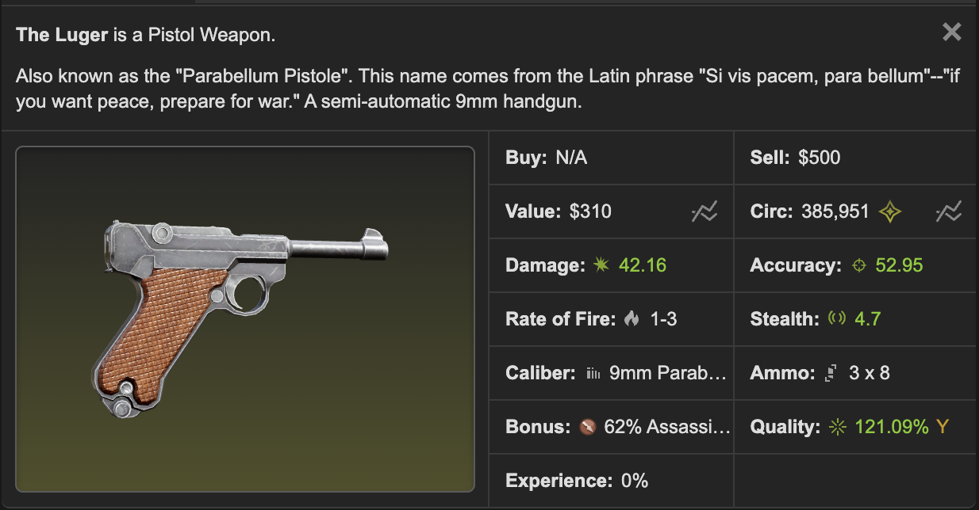
Example 2 - Let's add 62% on the damage, 42.16x162%=68.29 on only the first turn. While armalite base damage's 70 and have better accuracy --> it's trash!
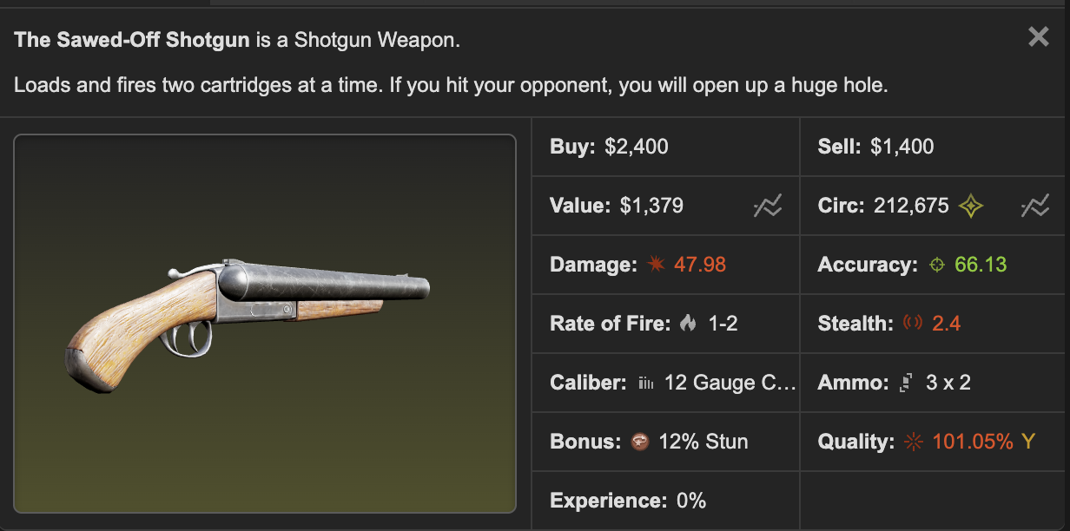
Example 3 - Accuracy is great. However, the damage is really weak (48 vs arma's 70), don't even mention the magazine size. 12% stun chance is just too low. Definitely not better than a normal armalite.
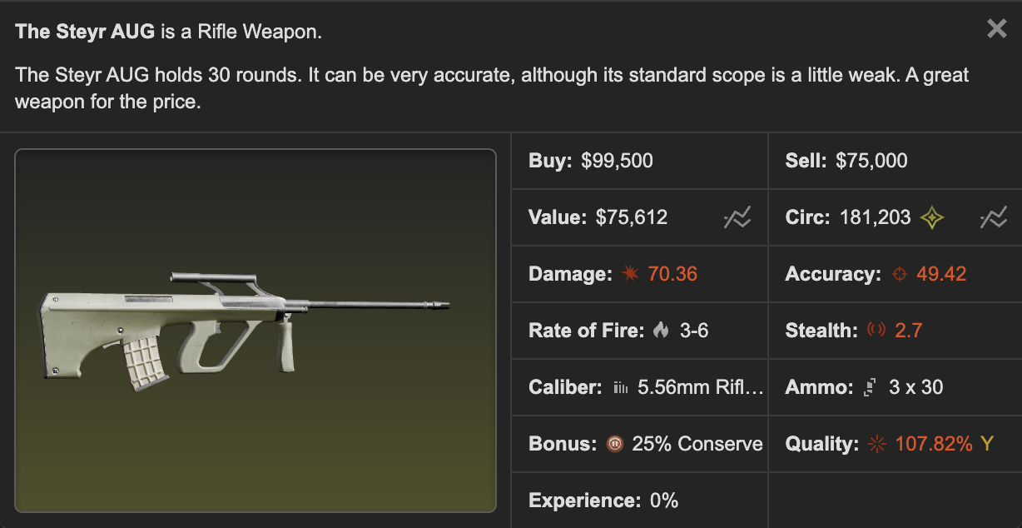
Example 4 - Damage is nice, but quite a bit lacking on accuracy (49 vs arma's 60). Conserve doesn't give any boost to damage. It does reduce the rate of fire quite a bit. I would rather use a recoil pad on a better weapon or a better accuracy enfield though.
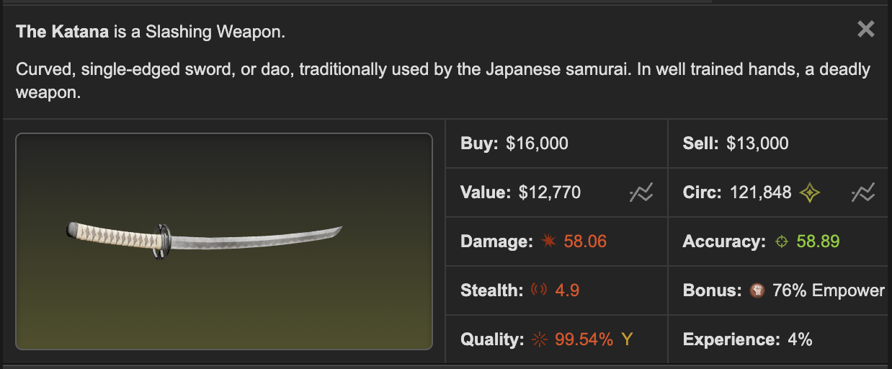
Example 5 - The base damage is 11 points lower than the armalite above. But have a look at the bonus, 76% empower, having 76% extra strength significantly boosts damage, I haven't even mentioned the +10% japanese blade bonus for those that completed the history education (58.06 damage --> 63.87). This weapon looks good!
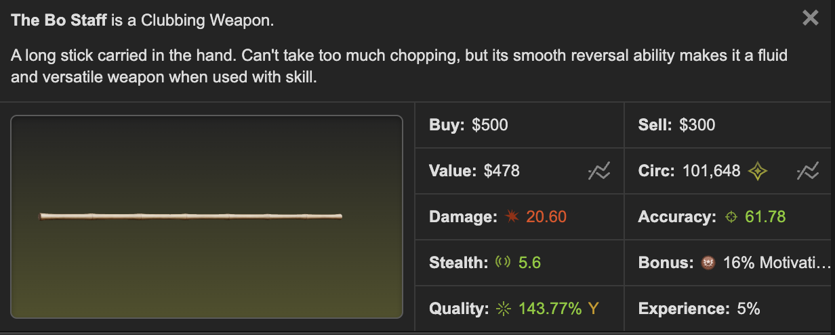
Example 6 - Even a kid can tell you it's trash, 20 damage??? But check the bonus - motivation. It looks like a nice little weapon to stack 5 motivation buffs on yourself while not damaging the target much. Do hope the motivation % to be higher! --> trash but useful in some occasion
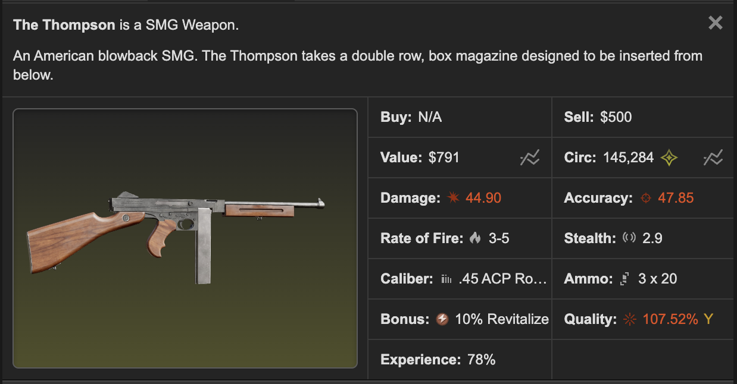
Example 7 - 44 dmg/47 acc is so far from the armalite's 70 dmg/60 acc. Bonus is revitalize tho! It's a great bonus to have when farming targets in halloween. The base stat still sucks but it's great in getting in extra hits when hitting weak targets.

The calculation above doesn't reflect exactly how things actually work, it is just my thought process to screen whether the weapon is crap or good.

If you want to compare purely damage/accuracy of different weapon, multiply damage by accuracy and compare the values. Usually accuracy is more important than damage, you can't damage people if you miss!

You should try to get RW weapons with a base stat of minimum 55 damage/55 accuracy, preferably 60+ on both, as close to the armalite's stat as possible. The only justification to buy BB weps to use is grind weapon XP for the Specialist merit.

This is one of the most common noob traps. There are so many traders trying to unload bb crap to noobs at a mark-up...

Three "classes" of bonus

Everything from this part onwards is really just my personal opinion. 100% recommend you to check out the other guides too to get a more balanced view on everything.

1. Damage
--> A weapon which boost your damage or hit chance in fights.
Examples: Achilles, Assassinate, Backstab, Berserk, Bleed, Blindside, Bloodlust, Comeback, Conserve?, Crusher, Cupid, Deadeye, Deadly, Double-edged, Double Tap, Empower, Execute, Expose, Finale, Focus, Frenzy, Fury, Grace, Parry?, Penetrate, Powerful, Puncture (Questionable after recent change), Quicken, Rage, Roshambo, Smurf, Specialist, Sure Shot, Throttle, Wind-up

2. Support
--> A weapon which improves the effectiveness of your other weapons or makes it easier for other people to take down the target
Examples: Eviscerate, Weaken, Wither, Slow, Cripple, Motivation, Suppress, Paralyze, Home Run, Stun?, Disarm

3. Utility
--> A weapon which improves your gains but has no effect in fights.
Examples: Warlord, Revitalize, Stricken, Plunder, Proficience, Irradiate

(Bonus bolded here is at least B tier in my opinion - you will want to buy weapons with these bonuses. The others are either niche or trash.)

I recommend a 1 damage/1 support/1 utility or 2/1/0 loadout:

E.g. (1/1/1) 25% Penetrate Enfield SA-80 (Damage) + 15% Warlord BT MP9 (Utility) + 16% Eviscerate Macana (Support)
E.g. (2/1/0) 18% Powerful Armalite M-15A4 (Damage) + 24% Slow BT MP9 (Support) + 72% Empower Yasukuni Sword (Damage)

If you only have the money for one RW weapon, I would recommend you to buy a "damage" type weapon that can be equipped in either a primary or melee slot to boost your battle effectiveness. However, if you have a specific goal, e.g. farming targets in halloween (revitalize) and mugging people (plunder), spend on that first.

I won't go too deep on which bonus is good or which one is a great buy... you can reference these guides:

- mug's Legendary Guide
- May 2025 Advanced Weapon Bonus Rankings
- Andyman's Weapon Bonus Guide
- RW Weapon Bonuses Reference Guide
- RW weapon selection and use [cake] Keep updated
- If you wanna suggest one to add here, let me know!

Some information on weapon bases

If you still have trouble figuring out what weapons are good, pick any of the bolded ones below, paired with a mid tier or better bonus it'll usually perform better than a normal armalite.

- Rifles - Best primary weapon, great ammo conservation - perfect for special ammo, many great mods are compatible to it, high damage, good accuracy (Best weapons: Armalite M-15A4 > Enfield SA-80 > Sig 552 > Tavor TAR-21)
- Shotguns - Primary weapon, high damage and fair accuracy, choke mod greatly improves damage (Best weapons: Jackhammer > Mag 7 = Benelli M4 Super)
- Pistols - Secondary weapon, Mid damage and mid accuracy. I can count at least 6 different types of ammos that can be used on pistols, wild right? (Best weapons: Qsz-92)
- SMG - Primary or secondary weapon, Mid damage and mid accuracy. Trash ammo conservation. (Best weapons: BT MP9)
- Piercing - Melee weapon, high damage and high accuracy... but (Best weapons: only on Diamond Bladed Knife > Macana)
- Slashing - Melee weapon, this is where all the japanese swords in! High damage, good accuracy, +10% damage boost if you have completed the history education. (Best weapons: Kodachi > Yasukuni Sword > Samurai Sword > Naval Cutlass (not japanese sword) > Katana)
- Clubbing - Melee weapon, high damage and high accuracy... but (Best weapon: only on Metal Nunchaku)
- Heavy arms (Heavy artillery, Machine guns) - Primary or secondary weapon, high damage but low accuracy, horrible ammo conservation and weak mod compatibility. (Best weapons - Stoner 96 > MIlkor NGL > China Lake) - I still don't suggest to use any unless the bonus is really good (stricken/warlord)

Each bonus only spawns on specific weapon categories. E.g. Revitalizes only spawn on SMG, you can't have a revitalize sword.

TLDR: You want to pick a great weapon base (anything bolded up there) with at least a mid tier bonus. You want to avoid trash weapon base, even if it has a great bonus unless it's orange or red. Utility weapon is an exception, it's OK to use a thompson revit... still feels a lot more satisfying to use a btmp9 or an armalite though.

Rate of Fire (RoF) and Magazine Size

This is usually an overlooked stat in a weapon. In battle, you want to avoid wasting turns to reload your guns and regulate your special ammo usage. That's why I often suggest a rifle or a melee weapon if you don't wanna bother with ammos. The Enfield SA-80 is an absolute beast when it comes to this. It has a 2-5 RoF and a magazine size of 30, meaning you can go 6-15 turns without reload. Even if an Armalite M-15A4 has better damage/accuracy than an Enfield, it only has a 3-5 RoF and magazine size of 15, meaning you can go only 3-5 turns without reload.

This is also why secondary weapons are trash and usually seen it as a support weapon. Most pistols and SMGs don't have enough magazine to last you more than 3-4 turns. Heavy arms are even worse, that RPG launcher has 1-1 RoF and magazine size of 1.... this means you need to reload every second turn, Who cares if a minigun can load up 200 ammo when you're burning 20-30 special ammo each hit (great for merits tho). Shotgun has great damage but rarely last over 3-4 turns too.

You generally want to look for guns with low rate of fire and big magazine size. In addition, I always recommend your first mod purchase to be the recoil pad - It's literally a 25% conserve in disguise.

Random Facts/Myths
- The empower and quicken effect only applies when you are using the weapon with the bonus on it. It is not a passive bonus.
- Using the extra magazine mod won't give you an extra magazine when you're using specialist weapon.
- Comeback won't work when you start a fight with <1/4 health. It only works when you are brought down to 1/4 health
- Execute only works when you make a damaging hit, misses or 0 damage won't kill the target.
- Execute doesn't work on NPCs.
- Warlord does not apply to bonus hit in a chain.
- You guys have more ideas?

Choosing RW armors

There are eight types of armors: Dune, Riot, Assault, Delta, Marauder, Vanguard, Sentinel, EOD

Dune armors (reduce incoming damage when below 1/4 life)

It's junk. Are you gonna use a weapon with comeback bonus? No? Then don't use dune. It's the same idea. In low stat fights, you are usually dead before hitting the 1/4 health mark. In high stat fights, execute pistols kill you instantly. Well.. to be fair, it's still better than combat set... I would rather use riot though.

Suitable for: People that use comeback weapons. Please don't buy dune armors.

Riot (reduce incoming melee damage)

People don't like it much but I think it's quite underrated. Great coverage, which reduces deadly crits on armor gaps. Best for missions/chains when fighting against inactive targets that usually has no ammo already. In low stat fights, opponents usually use melee weapon instead of guns, which makes it quite suitable for wars as well. Riot helmet protects you from pepper spray.

Suitable for: Missions, chains, anti-mugging. Good armors for newbies.

Assault (Reduce incoming gun damage)

Great for wars! A lot more expensive than riots and dunes. Assault set has an issue of low coverage, especially in the head region. If you are a dex whore or hate head crits, I'll suggest to use riot helmet instead and the rest assault pieces.

Suitable for: Wars. Entry armors for war hungry people.

Delta (Reduced negative status effect)

Incoming smoke grenades are less effective. RW debuffs (eviscerate, slow, weaken etc) are less effective too. Delta gas mask protects you against tear gas and pepper spray. Although delta gas mask has horrible coverage (even lower than assault) so head crit is gonna be a massive issue, I heard a couple people call them paper mask XD.

Suitable for: Dex whores. Top players that often get grouped on in wars.

Marauder (Increased life)

Health is the fifth stat, should I recommend this armor set to level holders? Great coverage on head and throat, high armor points too!

Suitable for: Top players that are not level holding.

Vanguard (Increased dexterity)

Full set gives you ~150-190% extra dex. Great for dex whores! I know there are some arguments on delta vs vanguard. Def main myself so no comment. Head crit is so deadly.

Suitable for: Dex whores

Sentinel (Increased defense)

Full set gives you ~150-190% extra def. Compared to marauder and assault, sentinel is the clear winner here. Head crits is still a problem here - EOD helmet + the rest sentinel pieces may be the way to go?

Suitable for: Def whores

EOD (Chance to fully block incoming damage)

EOD is OP, no joke. 30%+ chance to fully block an attack, can you even imagine? It also has the best coverage and highest armor point among all armor sets. Oh, you don't even need defensive stats, EOD will block most of the hits for you. The only issue is the price tag :p

Puncture guns are more effective against EOD.

Suitable for: People that are too rich. Glass cannon builds.

More data on armor comparison here: Torn Wiki / Premium Armor Comparison

A full set provides extra bonus (e.g. +10% reduced melee damage for full riot set and +25% defense for full sentinel set).

Comparing armor pieces (Yellow)

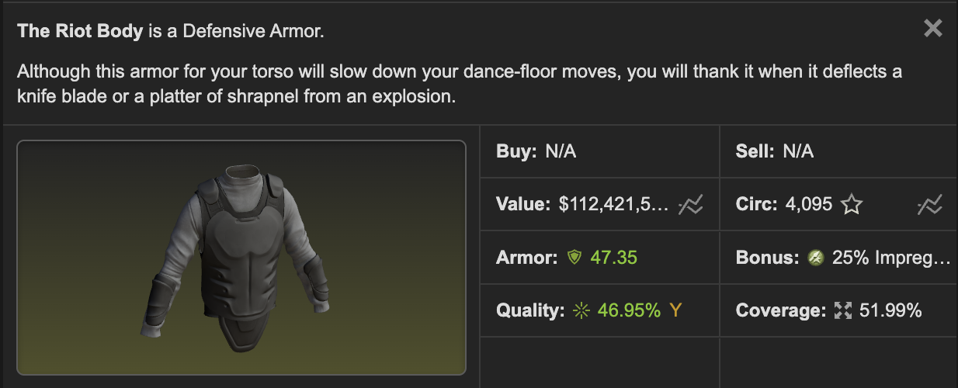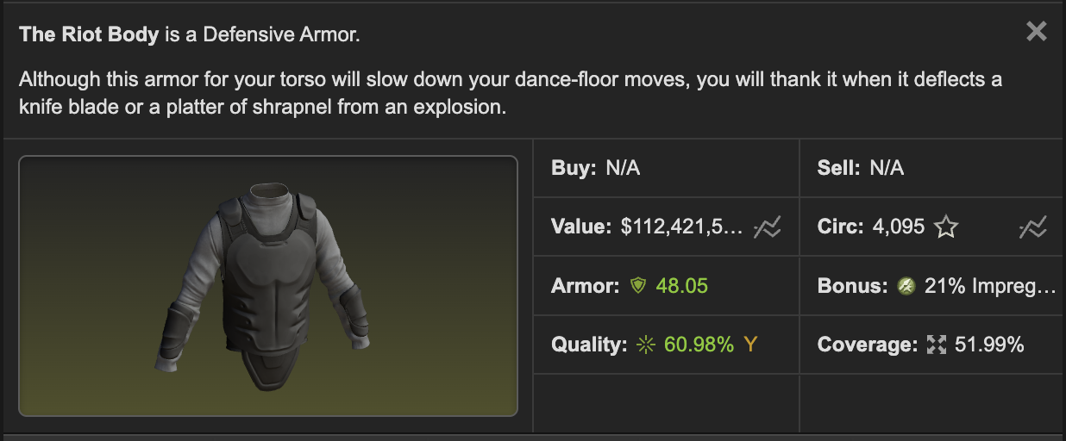

Which one is better? More bonus % or more quality (= more armor points = more damage mitigation) ?

My own method to compare: Every 1% quality is 1 point, every bonus % above base (20% for riot and assault, 30% for dune) is 5 points, extra 5 points if 26%+ for riot/assault and 37%+ for dune.

Riot Body 1: 46.95+5x5=71.95 VS Riot Body 2: 60.98+5x1=65.98 --> Riot Body 1 wins!

Of course, everyone has their own preferences. If you're using this armor solely for chains and missions, the impregnable bonus really helps. For more general use, quality will be the priority. The community generally thinks quality is more important in yellow range armors.

Comparing armor pieces (Orange/red)

I don't have much opinion on this. In orange range, the bonus becomes a lot more important. For EOD, the bonus is so powerful so that having a high bonus % is always the priority.

RW armors for poor people :(

Referencing mug's Legendary Guide, Dune vest + Riot Helmet provides great coverage and pepper spray immunity, costing you only around 200m! You can swap the Dune Vest for a Riot Body too.

For those that can easily afford yellow armors but not the orange/red ones, I suggest you to buy both Riot set and Assault set. Use riot in chains and missions, assault in wars, swap asasult helmet with riot helmet when you want pepper and extra head protection. This is what I use too myself.

Companies to further power up your defensive set-up: 7*+ Private Security Firm gives a 25% full set mitigation bonus, 10 stars Clothing Shop gives a 20% armor bonus.
Last edited by LegendaryKing11 on 01:13:12 - 25/02/26 (2 months ago)

Section 3:
Is RW trading still good?

"Market is sooooo saturated!"
"The market is dead look at yellow values"
"Before I could sell this arma achilles for 1b now it's barely bb"
"5% market tax and ched doesn't give a crap to script mugs!"
"Man... the market is so old, it has been 3 years already, any chance of profit is long gone..."
"That legendarydork guy is bidding up the whole auction I can't win shit lmao"

Noooo, this is just noises from traders that don't want competition!

Why trade RWs?

- Profit. Lots of profit. Have a look at the networth of any top RW traders. If you trade hard, getting on the networth leaderboard ($165b+, top 250 in Torn) within 1-2 years is very possible.
- High profit margins. Who cares that 0.5% margin you get from flipping xans. In the RW market, you can flip for double or even triple profit if you have the skill (and luck).
- Transparency of the market. It's way easier to learn values now, especially yellow range weapons/armors. Auction sales history is now fully mapped so you can just reference that. For selling price, you can just reference what other traders are selling on the new item market.
- Enjoy playing with the RW gear you bought while waiting for a sale! Fun+++

Starting out

You don't need a lot of money to start RW trading, around 200-300m liquid cash is OK. Of course, the more you have, the better. Activity is more important. If you cannot spend at least 30 minutes in the game every day, don't bother with trading.
The hardest part is always the first few flips. You dunno prices... you will make mistakes, probably a big loss too. This is normal. Just never give up!

The TLDR game plan is just... buy low, sell high, yeah. Longer version is, buy cheap from auction, put them on item market, advertise it in forums, wait for people to buy or negotiate with you, sell it at a profit.

Choose your niche(s)

- BB (bunker bucks) gear to caches (Risk: Very low, Profit: Very low) - You need to buy Big Al's bunker from point building, which costs you 2500 points. Your game plan is buy weapons under bb on auction or through private trade, then swap them to bunker bucks and then caches. Sell caches in bazaar to avoid market fees. However, this market is very saturated. Alternatively, you can sell these bb gear in item market for a slight mark-up. This attracts people who want a few more bunker bucks to complete a cache, or noobs that just want to buy the cheapest RW for absolutely no reason, especially on SMG, pistols and melee weapons.
- Upselling BB gear (Risk: Low, Profit: Low to Medium) - You are going to buy weps from auction at bb or a bit above that, and sell it at a markup. You need to have a good eye on what's slightly good and quite useful on certain occasions (e.g. jackhammer stun may work, but lorcin achilles nope.) Risk is low, you can just bunker or throw them back to auction if the weps don't sell and end up breaking even or a tiny loss.
- Warlords/Revitalizes (Risk: Low, Profit: Low) - These two are the most popular selling weapon bonuses. Great liquidity and stability, lots of buyers (esp. faction leaders), easy to find price references. There's at least 10 of these going through auction every day. Margin is tighter though. Be careful with revits when it's close to attacking events though.
- Premium yellow weapons (Risk: Medium, Profit: Medium) - Decent profit margins and quite easy to find price references. You want to find RWs with good weapon base + decent bonus. This means armalite, enfield, tavor, sig, dbk and macana. Lots of these going through auction every day and you'll never get bored!
- Bad orange weapons (Risk: Medium, Profit: Medium) - It's a bit like upselling BB gear. Usually only noobs buy these stuff. Margin is a bit better, but a bit more risky because usually only noobs buy these stuff.
- Top tier orange/red weapons (Risk: Very High, Profit: Very High) - Great opportunity in MASSIVE profits. Not a lot of traders deal with these weps so you won't feel much competition. Risk is extremely high, sells very slow, and unfriendly to traders with little liquid.
- Low quality yellow armors (Risk: Low, Profit: Low) - Buy them from auction and flip them for 10-20m more. Can sell very quick but expect to get undercut a lot. Good for a little side income.
- High quality yellow armors (Risk: Medium, Profit: Medium) - Sells slower than the low quality ones but has better margins.
- Orange/red armors (Risk: High, Profit: High) - Mostly manipulated by a couple rich people. Very difficult market to navigate and unfriendly to traders with little liquid.

I recommend new traders to start out with warlords/revitalizes or premium yellow weapons. The profit margins may not be the best, but risk is fairly low and you don't need a lot of money to start out. Even if you make mistakes loss won't be too significant. You do not need to buy Big Al's bunker unless your main business is turning BB trash to caches.

Learning prices

Revisit the previous section on how to find price references on item market, auction, forum and bazaar. Applies to traders too. The more you trade, the more you learn. There are so many random quirks and trends when it comes to pricing I don't even know how to summarise here... A big example is revit and axes go up a lot before halloween. Another is irradiate dbks and macanas are unreasonably expensive.

Navigating auction

Revisit my previous part on how auction works, how to stalk auction prices and general tips/tricks in bidding. Applies to traders too.

Oh, don't forget to say hello to the permanent merchant title...

Navigating the item market

Should you list on item market or bazaar? - Till now most RW traders still list on item market. Bazaar can be still viable. Bzimor/chedlist/weav3r is still up and the in-game bazaar directory has a section for RW weapons/armors.

Friendly reminder, double check every time you list something new or adjust prices. DO. NOT. MISS. A. ZERO. (e.g. Listing assault body at 25m instead of 250m)

You may want to add at least 5% more to your listing price to mitigate market tax. Potentially more to mitigate mugs, more on this later.

Setting your buyout prices

I'll suggest a minimum 20%-30% markup or undercut a similar listing on item market by a few mil. Expect to sell it at a minimum 10% discount when people negotiate, leaving you with about 10-20%+ profit.

Bigger markups on orange/reds since nobody is sure about their values anyway.

For caches and low quality armors sellers, just list them one dollar below the cheapest listing.

Check your listing prices every few days, if you get undercut, just undercut back. Most traders won't bother to recheck their listings, you probably won't get undercut back again in the coming 1-2 weeks, so you're good.

Patience is the key to success

This is not plushies and ecans. It takes days, weeks, and sometimes even months to sell a RW gear. Don't panic sell. Be patient. I mean it, please.

Adding this since this is a new phenomenon I have seen a lot among new traders. So many of you are looking for extremely quick profits. Well, I don't disagree with that, since this is also how I start out. But it's sometimes too much. Y'all just expect sales to go through within a day, even for higher end oranges/reds. It really isn't that easy. Please be patient when stuff doesn't sell. It doesn't mean you have overpaid. There are always end users out there that pay great, you just need to wait for them. DO NOT PANIC SELL!

Do not buy something that takes up too much of your liquid - it'll lead to panic selling and you'll lose the patience to sell it. I do not recommend touching any high end oranges/reds before you reach at least 10b networth.

I usually aim to sell a RW gear within 2 weeks and no more than 1-2 months. For orange/red, sometimes it's up to 3 months. More on how to handle stuff that doesn't sell ("dead inventory") later.

Stay liquid, lots of small profits > one big profit

You'll often face this dilemma: Should I accept this offer that gives me only a 10% profit or wait longer? I always recommend to take the profit and run. Really, there's no regrets! There are plenty of opportunities in auction, you can always get another cheap another day. Keep your inventory and money liquid. Don't get greedy.

Buy as low as possible - minimize risk

Very important to new traders. Put more effort into buying than selling. Selling is usually a waiting game, buying is the tough part. Try to get the best deal you can. Research price thoroughly. You're gonna end up with dead inventory and loss if you overbid.

The ideal buying price - you are confident you can throw the same item back to auction and still break even (or even get a small profit).

Ideally you should lose most of your auction bids. If you're winning more than half of your bids, you're probably overbidding. Be patient!

Dealing with mugs

Buy mugs/Script mugs

Funny enough, most RW buyers don't buy mug after buying directly from item market. They don't even negotiate and give traders the whole profit :D

Even if the buyer doesn't mug you... someone else will. Introduce.. the script muggers! They abuse websockets or torn API to detect movements in item market. When the script detects you sell something while you're offline, they mug you. The script is usually hosted in discord, when muggers hear a discord ping they'll click "start fight" and spam click their plunders.

Little history on this if you're interested. In patch notes #409, ched has implemented tracking on potentially illegal websocket connections that assist mug bots. It may be a small step to stop mug bots once and for all, but for now, nothing significant has been done. Using websockets to abuse mug bots have been confirmed illegal by staff in this thread. Many major script muggers are fedded and punished.

Script mugs are still around though. Torn API makes it easy to target RW sellers, even if it's generally slower than the websockets variant. You still need to protect yourself the same way . Let's hope ched eventually decide to eradicate them...

What can you do to protection your profits from script mugs?

- Include a "mug tax" in your listings - You raise your listing price for 15-20% to cover both market tax (5%) and potential mug loss (10-15%). There's a massive problem to this solution - your price becomes less competitive and people may ignore your listing, resulting in less sales.
- Self-hosp 24/7 when you're offline - You hire a mercenery (usually cost 3-4m) to give you a stricken hosp (8-9h) before you slept. Daytime use wrong blood bag when you go to take a short break (<1h). Self-bounties for a long break (3-5h). If you have very high battle stats (10b+), you can go overseas to avoid mugs, determined people may fly to your location and mug you though.
- Join a clothing shop - 75% mug protection. Reduce mug loss to 2-3%. Peace of mind when bidding in auction too.
- Join a property broker - Free anonymous listing. Mug loss *can* be 0. Take note some muggers may target traders that work in brokers. A massive disadvantage here is people can't negotiate with you.... And you can't open a forum post or advertise your stuff cos it'll just tell people you're the owner of those RW gear. After auction sales history go public, people can easily match the listings and mug you. I do see this works for some traders though.

Remainder - mug loss can be higher than 10%. Red plunders or repeated mugs if you're offline for a long time. Although most script muggers use assassinate guns so loss is usually limited at 7-8%.

Extended reading on script mugs in item market 2.0:
Item Market Mugbots - An Inside Look
Mugbot that bypasses 30s item market cache
Rip mug bots? (Added tracking on "potentially illciit" mug bots)
Death to websocket mug bots

Auction mugs

Quoting what I said in the first section - "Always have a ghost trade or a vault aside and minimize the time you'll be holding any money in your wallet. One tab for auction, one tab for the ghost trade/vault and one tab for items (for medding out)."

Trade mugs

Rare but it may still happen. Always self-hosp and have a ghost trade ready when you're finalising a trade.

Writing a forum post

You should have a forum post to gain visibility on your stuff.

You don't need to write excessive details or add in your sale pitches. Just show the stats and bonus and it'll speak for itself.

Post title, keep it simple. Can be something like. Selling [certain weapon], Selling warlords, xxx's RW shop, Cheap RW weapons etc

ALWAYS include a buyout price, don't tell people to send your offers or make bids etc, this just makes things complicated. "Buyout price" means if the buyer offers this price you'll sell it immediately.

An example of my post - Include the Weapon bonus, weapon base and your buyout price, (optional) damage/accuracy.
Make sure you always show you are willing to negotiate. the "obo" here means or best offer, inviting buyers to negotiate for a lower price.

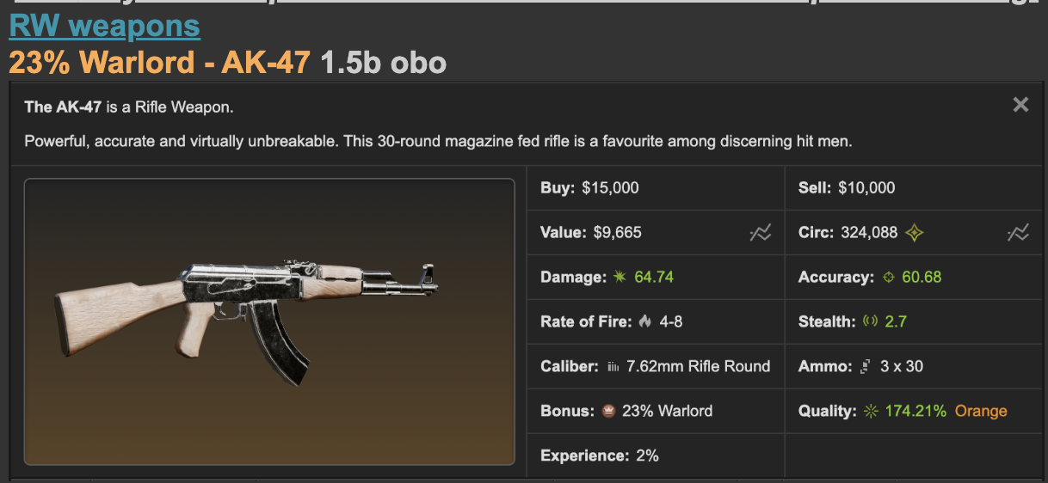

Every time you have made a sale, don't forget to ask your customers to like + comment on your post and add you as friend.
Example: ty! mind leave a review/like in my rw trading thread and add me as friend? thanks again and come back anytime! [link to your forum post]

A cheap trick to screw up the forum search function. Copy/paste your entire post every time as comment every time you bump your post. Get you a bit additional visibility.

Other ways to advertise

- Trade channel on any torn-related discord servers
- Trade Chat (Not recommended) - I mean if you have nothing to do and are happy to spam ads for 10 hours straight... go ahead
- Red/Orange weapon selling thread (Not recommended, ESPECIALLY if you get the item from auction. People there HATE traders)
- Private messaging people - This is hard work, you need to DM a lot of people though. Target faction leaders and people with good friend:enemy ratio.
- Private messaging auction buyers - Be careful and don't message a trader or it'll be weird.
- Looking for gear requests on forums - Sometimes people may make post requesting a specific weapon/armor.

Getting rid of "dead inventory"

If you have something that doesn't sell for a long time OR market price is higher than what you buy the weapon for. It may be time to cut loss.

Usually I'll just cut loss if it doesn't sell after 1-2 months. RW gear is always depreciating, the longer you hold it, the value goes even lower.

How to minimize loss? First you continue to drop prices. If you still don't get it sold, sell it in auction with a safe bid.

Social Skills/Negotiation Skills

Always give a counter-offer even if the offer's a lowball. Don't ignore any DMs or messages.

Always give a counter-offer even if the offer is good. Doesn't hurt to try for a bit more money :P, most buyers expect to buy it at a bit higher than the price they initially offer anyway.

Always try to cut the deal right on the spot. People will just buy something else instead of waiting for you to make up your mind.

You may find good buying opportunities outside of auction house. Befriend some cache gamblers! Don't lowball them (too much?) though.

Be nice to everyone and always avoid escalation.

Most RW traders are quite friendly but sometimes territorial. To be fair, you are directly competing with them! Make some trader friends and they may help you out with sales and give you good advice. Trading is boring without friends.

You may sometimes receive random messages from people selling their gear. The first thing you should always do is check if they have a "merchant" title or have won any auction in the past 1 month. If they do, they are probably trying to resell you auction stuff. Check auction sales history to confirm. Usually I will just call them out for it lol. If you wanna be nice just say no thank you. I do not recommend you to directly buy RWs from other players until you're more experienced with prices. Auction is good enough.

Common mistakes new traders always make (important)

- Offer to sell your stuff to other traders. Please, just don't. First it's a waste of time, you think traders are gonna offer above auction value? Second it's very offending. How would you feel if someone outbids you, wins the weapon, then DM you and tries to sell it to you at a markup?
- Mugging other traders or customers. Horrible for business. If you mug traders they will just bid you up for fun next time they see your name on auction.
- Buying from other traders. Are you sure you can flip for more profits?
- Post auction buys on red/orange weapon selling thread. People hate it a lot. The people who scroll that thread are mostly lowballers anyway so don't bother it.
- Excessive forum bumps - please refer to trading post guidelines
- Complain about getting outbidded by other traders or end users. - This is a free market! What do you expect?
- Invest on expensive RWs without the networth to do so. - Example, investing on a 3b wep with only 5b liquid. If you value the wep wrong and it ends up becoming a dead inventory because no one is willing to buy it higher... you'll lose a ton of money. You'll also get a lot of anxiety because a lot of money is concentrated on one single item.
- Buy BB crap and expect to get a very good sale on it. - No, you can't really convince a noob to take the ninja claw backstab or cupid ruger you overpaid in auction.
- Overbidding - Too little research on the true value of something. Then end up becoming dead inventory and a loss.
- Make a mess in their forum post and advertisement - Keep it simple, usually, the weapon speaks for itself. Excessive description and sales pitch on what it does is just going to be annoying.
- Trying to corner the market without a good plan - I am not against anyone trying to monopolise stuff. But traders nowadays react fast, the moment you have like 3-4 same items on market, everyone's gonna outbid your auction buys and undercut you hard. Make sure you have enough liquid and a good exit plan before you pull a monopoly.

More on market manipulation

Does it work? Absolutely. This is how the super top traders make most of their money anyway. Some of them even manage to build a meta around them. To be honest, traders manipulating stuff is actually good for the rw trading economy. The market would be dead so long ago if no one try to keep it under control. Probably all yellows are gonna be worth bb now!

Should you do it? Probably not. At least not before you understand the market well. You don't wanna hold a dozen similar RW gear and then end up getting stuck cos there's no good demand. Sometimes you may unconsciously manipulated the market. For example, you keep buying the same weapon type/bonus and end up hoarding a lot of them. It is important to diversify your inventory!

Tools to help with RW trading

Quite a lot. But not necessary for sure. I'll talk more about this in the advanced section.

Final words

Always, always, always pace yourself when trading RWs. It's a tough market. You'll be mugged, undercut, lowballed, outbidded, yelled at, made enemies, etc, It isn't pleasant sometimes. If you feel burnt out, please consider to take a break, just forget about what's happening in auction and retrieve all your inventory from item market/bazaar.

The most valuable thing trading takes from you is TIME. It's something you can never get it back. Is it worth investing your time in trading virtual weapons and accumulating pixel money? Are you forced to trade because ched nerfed so many income sources?

We all play torn for fun. Not to make it a second job. If you ever find trading becomes not enjoyable, just leave the trading scene and come back (or never) when you feel up to it again.

Thanks for attending my TED talk.

